**Introduction to ASP.NET Web API**

**Introduction to ASP.NET Web API:**

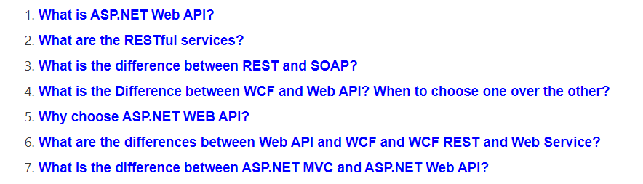

**What is ASP.NET Web API?**

The term **API** stands for “**Application Programming Interface**“. **ASP.NET Web API** is a framework, provided by Microsoft, which makes it easy to build **Web APIs**, i.e. **HTTP** based services. The **ASP**.**NET Web API** is an ideal platform for building Restful services on the top of the .NET Framework. These Web API services can be consumed by a variety of clients such as

1. Browsers
2. Mobile applications
3. Desktop applications
4. IOTs, etc.

The most important thing to keep in mind is that we can develop both Restful and Non-Restful Web Services using the ASP.NET Web API framework. But mostly this framework is used to create RESTful services. In short, this framework does not provide any specific architectural style for creating the services. In this article series, we are going to discuss creating RESTful services from scratch using the Web API framework.

**What are the IOTs?**

IOTs stands for Internet Of Things and it is actually a network of physical devices, buildings,  vehicles, and other items that are embedded with electronics, sensors, software, actuators, and network connectivity that enable these objects to collect and exchange the information or you can say data.

In other words, we can say, the Internet Of Things (IoT) are the objects or devices which should have an IP address and they can communicate with other Internet-enabled devices and objects over the Internet. Examples of IoT include security systems, thermostats, electronic appliances, cars, etc, in addition to laptops, desktops, and smartphones.

**What are the RESTful services?**

The term **REST** stands for **Representational State Transfer**. REST was first introduced in the year 2000. The REST is actually an architectural pattern that is basically used for creating Web API’s which uses HTTP as the communication method. This REST architectural pattern specifies a set of constraints and those constraints a system should follow to be considered as a Restful Service. The following are the REST constraints.

**Client-Server Constraint:**

The **Client-Server Constraint** is the first constraint of Rest Architectural Pattern. This constraint specifies that a Client sends a request to the server and the server sends a response back to the client. This separation of concerns supports the independent development of both client-side logic and server-side logic.

**Stateless Constraint:**

The next constraint of Rest Architectural Pattern is the **Stateless Constraint**. The Stateless Constraint specifies that the communication between the client and server should be stateless between the requests. That means we should not be storing any information about the client on the server. The request that comes from the client should contain all the necessary information that is required for the server to process that request which will ensure that each request coming from the client will be treated independently by the server.

**Cacheable Constraint:**

The next Constraint is **Cacheable Constraint**. Some of the master data provided by the server like a list of countries, or list of cities or list of the department in a company does not change that often. The Cacheable Constraint states that let the client decide how long this data is good for so that the client does not need to come back to the server again and again for the same data.

**Uniform Interface:**

The **Uniform Interface** constraint defines an interface between the client and the server. To understand the uniform interface constraint, we need to understand what a resource is and the HTTP verbs – GET, PUT, POST and DELETE. From the REST API Point of view, the resources typically represent the data entities such as Product, Student, Customer, etc. The HTTP verb such as GET, POST, PUT, and DELETE which is sent with each request from the client tells the API what to do with the resource. Each resource in a REST API is identified by a unique URI (Uniform Resource Identifier). The following table shows some typical requests that you see in an API

* /Students if the verb is GET here it is going to get the list of students
* /Students/1 if the verb is GET going to fetch student where the student id is 1
* /Students if the verb is POST, it going to create a new student
* /Students/1 if the verb is PUT it is going to update the student whose id is 1
* /Students/1 if the verb is DELETE, then it is going to delete a record where the id is 1.

Another concept that is related to Uniform Interface is **HATEOAS**. The HATEOAS stands for **Hypermedia as the Engine of Application State**. This states that in each request there may be a set of hyperlinks that will let you know what other actions or operations you can perform on the resource. If this is not clear at the moment, don’t worry, we will discuss the concept in a later article.

There are 2 other constraints as well

**Layered System:**

The REST allows us to use a layered system architecture where we deploy the APIs in server A, and store data on server B and authenticate requests in server C., For example, a client cannot simply tell whether he is connected directly to the server or to an intermediary server on the way.

**The code on Demand (optional):**

The code on Demand constraint is an optional constraint. We will discuss this constraint in a later article.

**What is the difference between REST and SOAP?**

Let us discuss the difference between the REST and SOAP service:

1. The term SOAP stands for Simple Object Access Protocol whereas the term REST stands for Representational State Transfer.
2. SOAP is based on XML protocol which is built on top of the HTTP or sometimes TCP/IP or SMTP whereas the REST is actually not a protocol rather it is an architectural pattern i.e. resource-based architecture.
3. The SOAP provides specifications for the implementation of both stateless and state-full whereas REST is completely based on stateless implementation.
4. SOAP enforces the message format to be XML whereas REST does not enforce the message format as XML or JSON.
5. The SOAP message contains an envelope which includes the SOAP headers and SOAP body where we actually store the information or data that we want to send whereas the REST uses the built-in HTTP headers (with a variety of media-types) to store the data that we want to send and then uses the HTTP Verb such as GET, POST, PUT and DELETE methods to perform the CRUD operations.
6. SOAP uses the interfaces and named operations to expose the service for the client to consume whereas the REST uses URI to expose the resources and methods such as GET, POST, PUT, and DELETE.
7. The SOAP Performance is slow when it compared to REST.

**What are the Differences between the WCF Service and Web API Service? When to choose one over the other?**

The term WCF stands for Windows Communication Foundation and it is one of the most popular choices available in .NET Framework for creating the REST services. The problem with WCF is that we need to do a lot of configuration to turn a WCF service into a REST service. So, if you want to develop a REST service nowadays, then the first and most preferable choice is ASP.NET Web API, which is specifically designed for this purpose i.e. to build REST Services.

Then the question that comes to our mind when should we use WCF? let discuss that.

The WCF is basically used to develop the services which are **transport/protocol** independent. For example, you want to build a single service which can be consumed by 2 different clients – Let’s say, a Java client and .NET client. The Java client wants the protocol (transport protocol) to be HTTP and he also wants the message to be in XML format for interoperability, whereas the .NET client wants the protocol (transport protocol) to be TCP and he wants the message to be in the binary format for performance. If this is the scenario, then WCF is the right choice. What you need to do here is, just develop a single WCF service, and then expose 2 endpoints one for each client (i.e. one endpoint for the Java client and the other endpoint for the .NET client).

The thing that you need to remember is that you can use the WCF to create the REST services. The problem is it’s bit more configuration to turn a WCF Service to WCF Rest Service. So, if you are stuck with the .NET Framework 3.5 or you have an existing SOAP service and you want to add REST to reach more clients, then use WCF.

If you don’t have the limitation of .NET Framework 3.5 or if you want to develop a brand new restful service then go for ASP.NET Web API.

**Why Do I need to choose ASP.NET WEB API?**

Nowadays, a web application is not sufficient or enough to reach all its customers. Peoples are becoming very smart; they are using different types of devices such as mobile, iPhone, tablets, etc. in their daily life. These devices are having a lot of apps which makes their life easy. In simple words, we can say that we are moving towards the apps world from the web.

So, if we want to expose our data (business data) to the browsers as well as to all these modern devices apps in a fast, secure and simple way, then we should have an API that should be compatible with browsers as well as all these modern devices.

The ASP.NET WEB API is a great framework for building HTTP services that can be consumed by a broad range of clients including browsers, mobiles, iPhones, and tablets.

**What is the difference between WCF and WEB API and WCF REST and Web Service?**

The .NET framework has a number of technologies that allow us to create HTTP services such as Web Service, WCF, WCF Rest and now WEB API. Following are the differences between these four:

**Web Service:**

1. The Web Service is based on SOAP and it returns the data in XML format.
2. It supports only the HTTP protocol.
3. Web Service is not an open source but it can be consumed by any client who understands XML.
4. It can only be hosted on IIS.

**WCF:**

1. WCF is also based on SOAP and it also returns the data in the form of XML.
2. Unlike Web service, WCF supports different types of protocols (transport protocol) such as TCP, Named Pipes, HTTP, HTTPS, and MSMQ.
3. The main problem with WCF service it required lots of configuration which is a headache for a developer.
4. Like Web Service, WCF is also not open source but it can be consumed by any client who understands XML.
5. WCF can be host within in the application or on IIS or using window service.

**WCF Rest:**

1. To use a WCF service as WCF Rest service we have to enable webHttpBindings.
2. WCF Rest supports the HTTP verbs such as GET and POST by using the [WebGet] and [WebInvoke] attributes respectively.
3. To use other HTTP verbs you have to do some configuration in the IIS so that it will accept the request of that particular verb on .svc file
4. It supports different data formats such as XML, JSON, and Atom format.

**WEB API:**

1. The Web API Framework is a new framework that is basically used for developing HTTP based services in easy and simple way.
2. Unlike WCF Rest Service, it uses the full HTTP features such as URIs, request/response headers, caching, versioning, and various data formats.
3. The ASP.NET Web API also supports most of the MVC features such as routing, controllers, actions, filter, model binders, IOC container, dependency injection, unit testing which makes it more simple and robust.
4. WEB API Services can be hosted on IIS or within the application
5. The Responses in Web API Services are formatted by MediaTypeFormatter into JSON, XML or any custom format you want.

**What is the difference between ASP.NET MVC and ASP.NET Web API?**

The differences between the ASP.NET MVC and ASP.NET Web API are as follows

1. ASP.NET MVC is used to create web applications that return both views and data but ASP.NET WEB API is used to create rest full HTTP services with an easy and simple way that returns only data, not view.
2. WEB API helps to build REST-full services over the .NET Framework and it also supports content-negotiation(it’s about deciding the best response format data that could be acceptable by the client. it data format may be JSON, XML, ATOM or any other custom formatted data) which are not in MVC.
3. WEB API also takes care of returning data in a particular format like JSON, XML or any other based upon the Accept header in the request. The ASP.NET MVC Framework can return data only in JSON format using the JsonResult return type.
4. In WEB API the request is mapped to the actions based on HTTP verbs but in MVC it is mapped to the action name.
5. We can mix WEB API and MVC controller in a single project to handle advanced AJAX requests which may return data in JSON, XML or any others format and build a full-blown HTTP service. Typically, this will be called WEB API self-hosting.
6. Moreover, WEB API is lightweight architecture and except for the web application, it can also be used with smartphone apps.

**Creating Web API Application**

**Creating Web API Application using Visual Studio**

1. **How to Create an ASP.NET Web API application using Visual Studio?**
2. **Understanding the Folder structure and Auto-Generated Code in Web API Application.**
3. **Understanding the Web API Controller.**
4. **What is GET, POST, PUT and DELETE Http Verbs in Web API?**
5. **Understanding the WebApiConfig in ASP.NET Web API Application.**
6. **Understanding the Request Verbs, Request Header, Request Body and Response Body.**

**Creating Web API Application using Visual Studio:**

First, open the Visual Studio and then select **File => New Project** as shown in the below image.

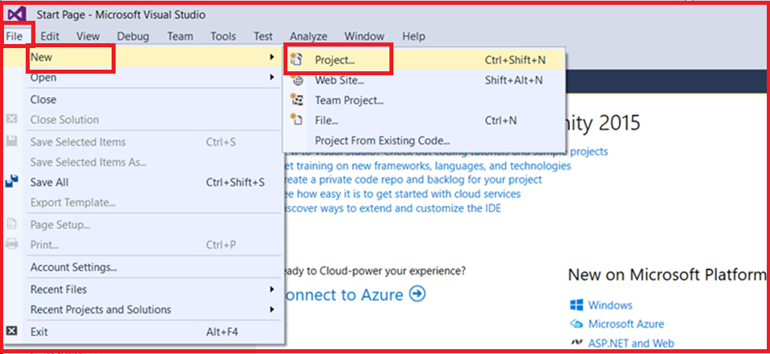

In the “**New Project**” window Select “**Visual C#**” under the “**Installed – Templates**” and From the middle pane select the **ASP.NET Web Application** and name the project as “**FirstWebAPIDemo**” and then click on the “**OK**” button as shown in the below image.

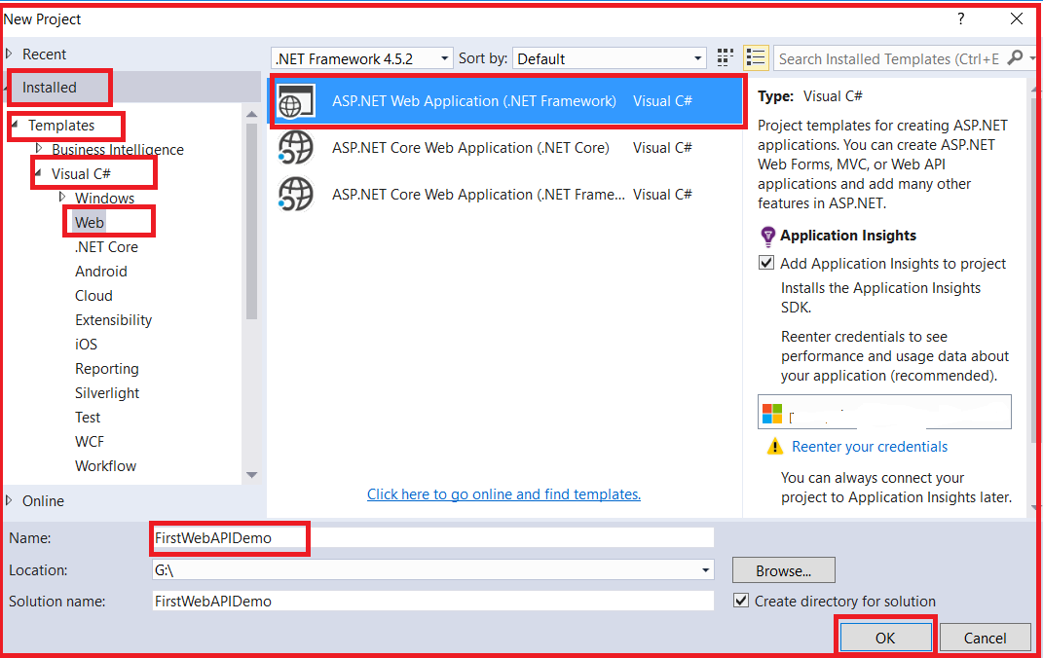

Once you click on the **OK** button, then a new window will open with Name **New ASP.NET Project** for selecting project Templates and from that window select the **Web API** project template and click on the **OK** button as shown in the below image.

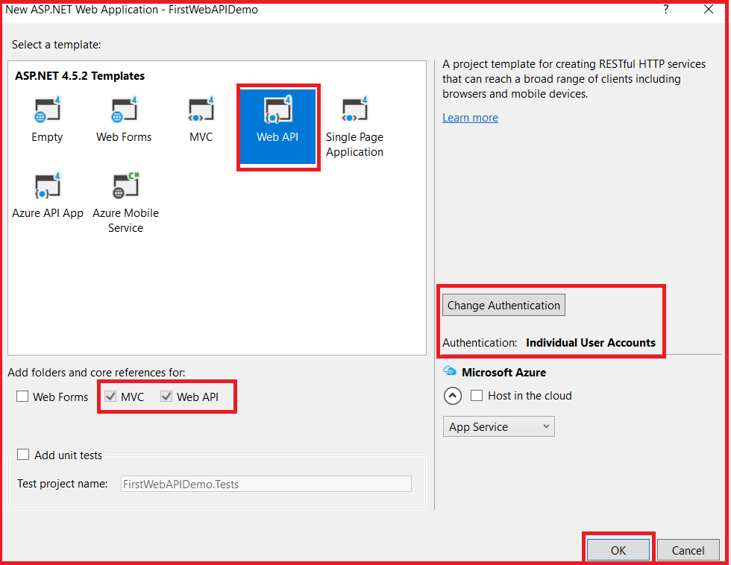

Once you click on the OK button, It will take some time to create the project for us.

**Understanding the Folder Structure of Web API Application:**

If you have worked with ASP.NET MVC Framework, then the project folder structure should be familiar to you as shown below.

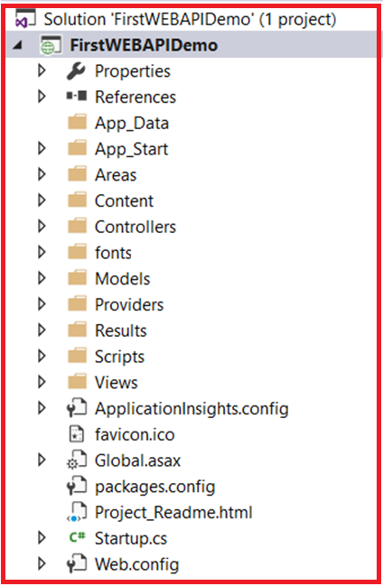

Here, we have separate folders for Models, Views, and Controllers and moreover, within the Controllers folder, we have both MVC as well as Web API Controller as shown in the below image.

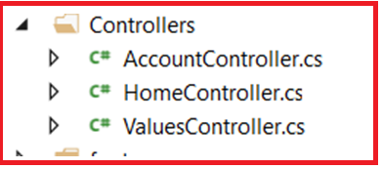

The important thing to keep in mind is that the Web API Controllers are different from MVC Controllers. In our example, the ValuesController is WebAPI Controller.

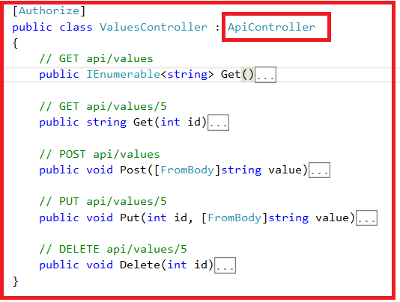

If you observe the above **ValuesController** Class, then you will see that it inherits from the **ApiController**class which is present in **sytem.web.http** namespace.

Further, if you notice that the **HomeController** class is an MVC Controller, which is inherited from the **Controller**class that is present in **System.Web.Mvc** namespace as shown in the below image.

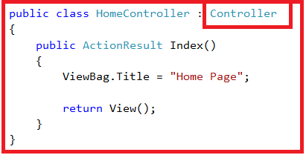

**Here we are going to focus on the Web API controller (i.e. Values Controller).**

Notice that in the **ValuesController** we have methods such as Get, Put, Post and Delete that map to the HTTP verbs GET, PUT, POST and DELETE respectively as shown in below image.

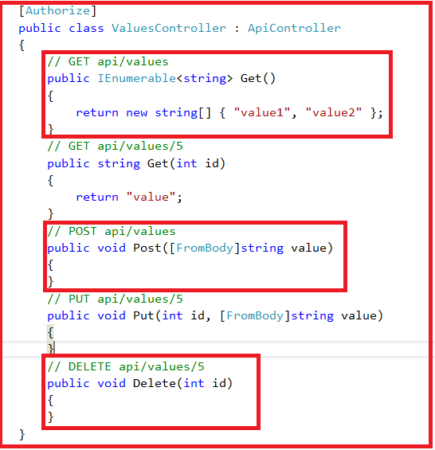

We have 2 overloaded versions of the Get() method – One method without any parameters and the other one with the id parameter. Both of these methods respond to the **GET** HTTP verb depending on whether the id parameter is passed or not in the URL.

Now let’s look at the default route for our Web API project. We have the **Application\_Start()** method within the **Global.asax**file. This method is executed when the application starts for the first time. In the **Application\_Start()** method we have the configuration for Filters, Bundles, etc. as shown below.

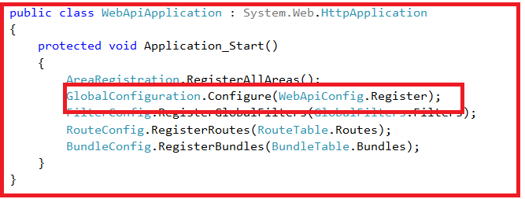

The one that we are interested in here is the configuration for our Web API project, which is in **WebApiConfig.Register()** method. So right-click on the **WebApiConfig.Register** method and then select the “**Go To Definition**” from the context menu which will take you to the **Register()** method of the **WebApiConfig** class as shown below.

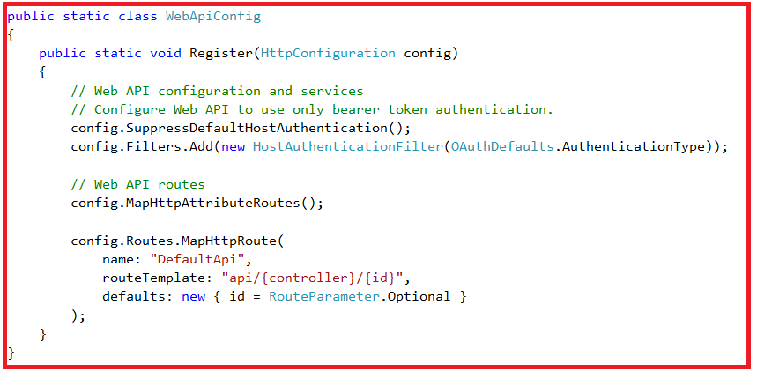

**This class is in the App\_Start folder.**

You can see a default route is configured within the **Register()** method for our Web API project. The Web API routes are different from the MVC routes. You can find the MVC routes in **RouteConfig.cs** file which is present in the **App\_Start** folder.

The default route in Web API starts with the word **API** followed by a **/** and then the name of the **controller** and then another **/** and an optional id parameter as shown below.

**“api/{controller}/{id}”**

At this point, if you use the following URI in the browser, you will get an error stating – **Authorization has been denied for this request.**

**http://localhost:xxxxx/api/values**

To get rid of this error, comment Authorize attribute on the **ValuesController** class. This is related to security which we will discuss in a later article.

Now if you issue the URI **http://localhost:xxxxx/api/values** in the browser, then you should see the following XML as the result

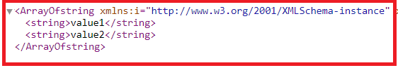

**Let us understand what is going on here.**

The name of the controller is “**values**“. So if you issue a URI **http://localhost:portnumber/api/values**, then the Web API Framework is going to look for a controller with name **Values +**the word **controller**i.e. **ValuesController**in your application.

So if you have specified values in the URI it is going to look for **ValuesController**, if you specify **Products**, then it is going to look for **ProductsController**.

In a real-world application, this might be the domain name, for example, **http://dotnettutorials.net/api/values**The browser is issuing a GET request which maps to the Get() method in the **ValuesController** class. The GET() in the values controller is returning value1 and value2 which is what we see in the browser.

We have another overload of GET() method within the Values Controller which takes the Id parameter. If you remember with the default route within the WebApiConfig file, we specified the id parameter is optional. This is the reason why we are able to call the GET method with or without the Id parameter. So, if you specified the id parameter in the URI, then, the Get() method with the id parameter in values controller is going to be called

If a controller with the specified name is not found by the Web API Framework, then the Framework will an error. For example, in our application, if we comment “ValuesController” class in our project and then use the URI **/api/values** then you will get the following error

**No HTTP resource was found that matches the request URI ‘http://localhost:15648/api/values’. No type was found that matches the controller named ‘values’.**

**Let’s discuss about POST, PUT and DELETE.**

In a database table row, we can perform the following 4 actions

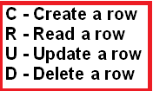

From the ASP.NET Web API point of view, these 4 actions correspond to GET, POST, PUT and DELETE verb as shown below

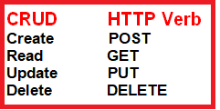

**Let us discuss some terms and concepts which are related to HTTP request and response.**

**Request Verbs:**

The HTTP verbs such as GET, POST, PUT and DELETE describe what should be done with the Web API resource. For example, do you need to read, create, update or delete an entity? The HTTP Verbs GET, PUT, POST and DELETE are the most commonly used verbs in real-time applications. For the list of the complete  HTTP verbs, please check the following URL

[**http://www.w3.org/Protocols/rfc2616/rfc2616-sec9.html**](http://www.w3.org/Protocols/rfc2616/rfc2616-sec9.html)

**Request Header:**

When a client sends the request to the server, the request contains a header and a body. The header of the request contains some additional information such as what type of response the client required. For example, the client wants the response to be in XML or JSON format.

**Request Body:**

The Request Body contains the data that you want to send to the server. For example, a POST request contains the data in the Request Body for the new item that you want to create. The data may be in the form XML or JSON.

**Response Body:**

The Response Body contains the data that is sent as a response from the server. For example, if you request a specific employee, then the response body includes the employee details either in the form of XML or JSON.

**Response Status codes:**

The Response Status Codes are the HTTP status codes that will specify the status of the request. The most common status codes are 200/OK, 204/No Content, 500/Internal Server Error, 404/Not Found. If you want to see the complete list of HTTP status codes then please follow the below

[**http://www.w3.org/Protocols/rfc2616/rfc2616-sec9.html**](http://www.w3.org/Protocols/rfc2616/rfc2616-sec9.html)

To perform the GET, POST, PUT & DELETE actions, we will use a tool called Fiddler. You can download fiddler from the following link

[**https://www.telerik.com/download/fiddler**](https://www.telerik.com/download/fiddler)

**Modify the ValuesController as shown below, so that it can support POST, PUT and DELETE actions.**

**public** **class** ValuesController : ApiController

**{**

**static** List**<**string**>** strings = new List**<**string**>()**

**{**

"value0", "value1", "value2"

**}**;

// GET api/values

**public** IEnumerable**<**string**>** Get**()**

**{**

**return** strings;

**}**

// GET api/values/5

**public** string Get**(int** id**)**

**{**

**return** strings**[**id**]**;

**}**

// POST api/values

**public** **void** Post**([**FromBody**]**string **value)**

**{**

strings.Add**(value)**;

**}**

// PUT api/values/5

**public** **void** Put**(int** id, **[**FromBody**]**string **value)**

**{**

strings**[**id**]** = **value**;

**}**

// DELETE api/values/5

**public** **void** Delete**(int** id**)**

**{**

strings.RemoveAt**(**id**)**;

**}**

**}**

At the moment the **Post(), Put() and Delete()** methods in the **ValuesController**are returning void. That is the reason why we are getting the status code **204 No Content**. In ASP.NET Web API, an action method that returns void will send the status code **204 No Content** by default, but we can control this behavior which we will discuss in a later article.

**How to add Swagger in Web API**

**How to add Swagger in Web API Application**

1. **What is Swagger?**
2. **How to Add Swagger to Web API Application?**
3. **How to Configuring Swagger in ASP.NET Web API?**
4. **Understanding the Swagger UI.**
5. **How to enable Swagger to use XML comments?**

**What is Swagger?**

The Swagger is a simple but powerful representation of the RESTful API. Nowadays most of the developers are using Swagger in almost every modern programming language and deployment environment to document. With a Swagger-enabled Web API, you will get interactive documentation, client SDK generation as well as discoverability.

**How to Add Swagger to Web API Project?**

To add Swagger to your ASP.NET Web API project, you need to install an open-source project called [Swashbuckle](https://www.nuget.org/packages/Swashbuckle/" \t "_blank) via NuGet as shown below.



Once the package is installed successfully, navigate to the **App\_Start** folder in the Solution Explorer. You will find a new file called **SwaggerConfig.cs**. This is the file where Swagger is enabled and any configuration options should be set here.

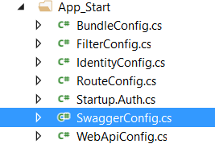

**How to Configure Swagger in ASP.NET Web API Application?**

To enable Swagger and Swagger UI, modify the **SwaggerConfig** class as shown below

**namespace** *FirstWebAPIDemo*

**{**

**public** **class** SwaggerConfig

**{**

**public** **static** **void** Register**()**

**{**

var thisAssembly = typeof**(**SwaggerConfig**)**.Assembly;

GlobalConfiguration.Configuration

.EnableSwagger**(**c =**>** c.SingleApiVersion**(**"v1", "First WEB API Demo"**))**

.EnableSwaggerUi**()**;

**}**

**}**

**}**

Start a new debugging session by pressing the F5 key and navigate to **http://localhost:[PORT\_NUM]/swagger** and then you should see the help pages for your APIs.

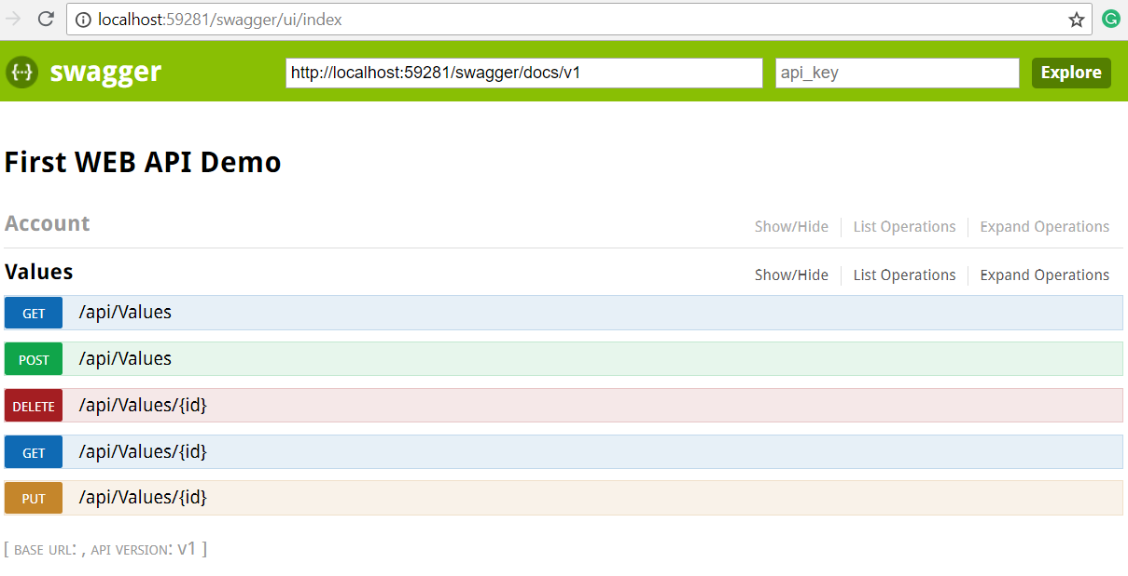

Ok. That’s cool. Now expand an API and then click on the “**Try it out!**” button which will make a call to that specific API and return results as shown in the below image.

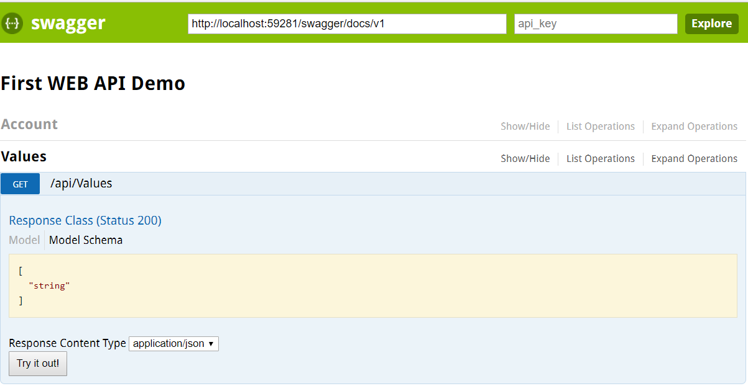

Here click on the Try it out Button which will display the result as shown below.

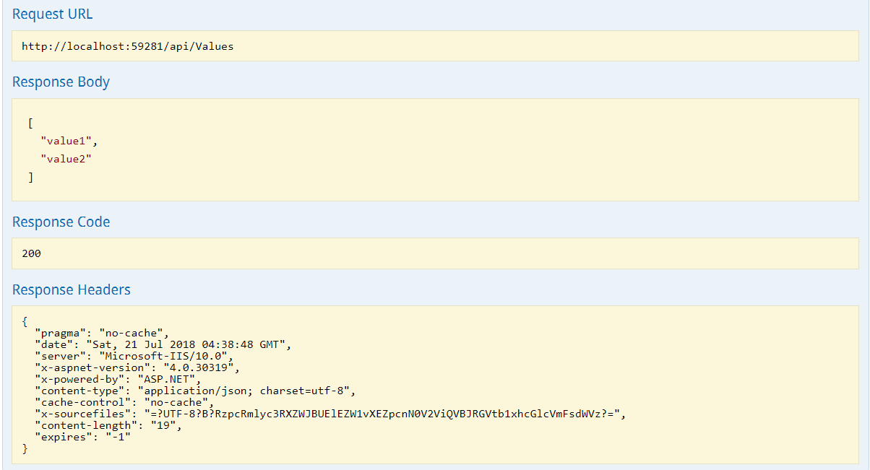

In the same way, you can test all other methods.

**How to enable Swagger to use XML Comments in ASP.NET Web API Application?**

As of now, we use the minimum configuration to get started. But now we are going to add more customization. We can tell the Swashbuckle to use our custom XML comments to add more details about our APIs to the Swagger metadata.

First, we need to enable XML documentation file creation during the build. In the Solution Explorer right-click on the Web API project and click on the Properties. Click the Build tab and navigate to Output. Make sure the XML documentation file is checked. You can leave the default file path. In our case its bin\FirstWebAPIDemo.XML as shown below

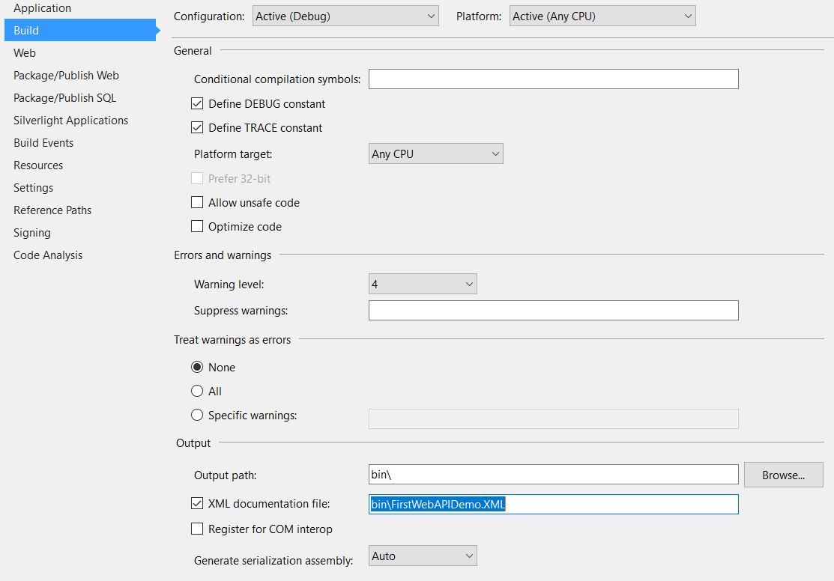

Next, we need to tell the **Swashbuckle** to include our XML comments in the Swagger metadata. To do this we need to add the following line to **SwaggerConfig.cs**. Make sure to change the file path to the path of your XML documentation file.

**c.IncludeXmlComments(string.Format(@”{0}\bin\FirstWebAPIDemo.XML”, System.AppDomain.CurrentDomain.BaseDirectory));**

**Configuration, so far**

**namespace** *FirstWebAPIDemo*

**{**

**public** **class** SwaggerConfig

**{**

**public** **static** **void** Register**()**

**{**

var thisAssembly = typeof**(**SwaggerConfig**)**.Assembly;

GlobalConfiguration.Configuration

.EnableSwagger**(**c =**>**

**{**

c.SingleApiVersion**(**"v1", "First WEB API Demo"**)**;

c.IncludeXmlComments**(**string.Format**(**@"{0}\bin\FirstWebAPIDemo.XML",

System.AppDomain.CurrentDomain.BaseDirectory**))**;

**})**

.EnableSwaggerUi**()**;

**}**

**}**

**}**

Let’s add some XML documents to our API methods as shown below. Here we are adding XML Document to the get method. Modify the Get method as shown below.

/// <summary>

/// Get All the Values

/// </summary>

/// <remarks>

/// Get All the String Values

/// </remarks>

/// <returns></returns>

**public** IEnumerable**<**string**>** Get**()**

**{**

**return** new string**[]** **{** "value1", "value2" **}**;

**}**

Run the application and navigate back to **/swagger**. You should see more details added to your API documentation as shown below.

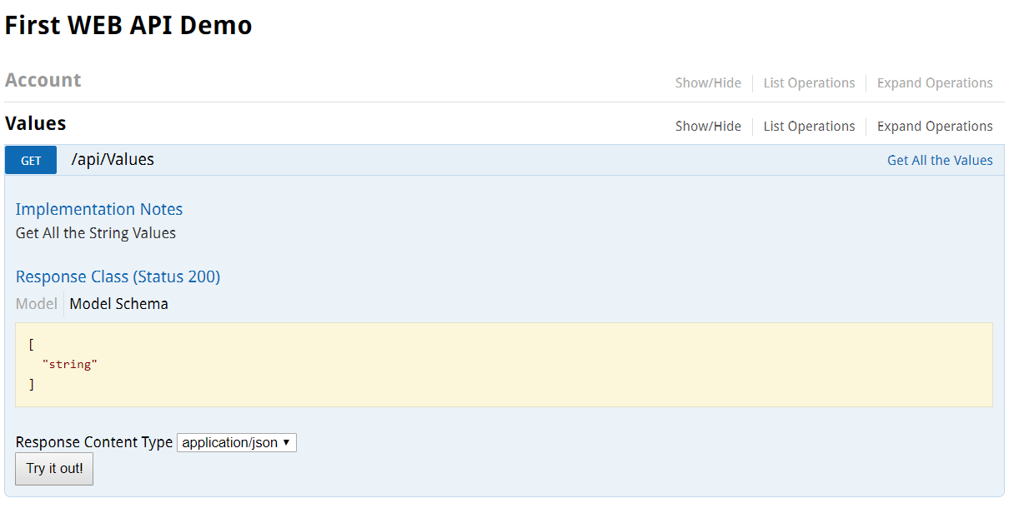

**How to use Fiddler to test Web API**

1. **What is Fiddler?**
2. **How to download and Install Fiddler?**
3. **How to test Web API Services using Fiddler?**
4. **Understanding the Request and Response of Fidder.**
5. **How to use Fiddler to test Get, Post, Put and Delete Request?**

**What is Fiddler?**

The Fiddler is a free debugging proxy tool which is used for testing restful web services. We can use Fiddler to compose and execute different HTTP requests to our Web API and check the HTTP response.

Let’s see how to use Fiddler to send an HTTP request to our local ASP.NET Web API Services and check the response.

**Step1:**Download and install Fiddler from [here](https://www.telerik.com/download/fiddler).

**Step2:**Once the Fiddler is successfully installed, click on the **Fiddler.exe** to open Fiddler. It will look like the image shown below.

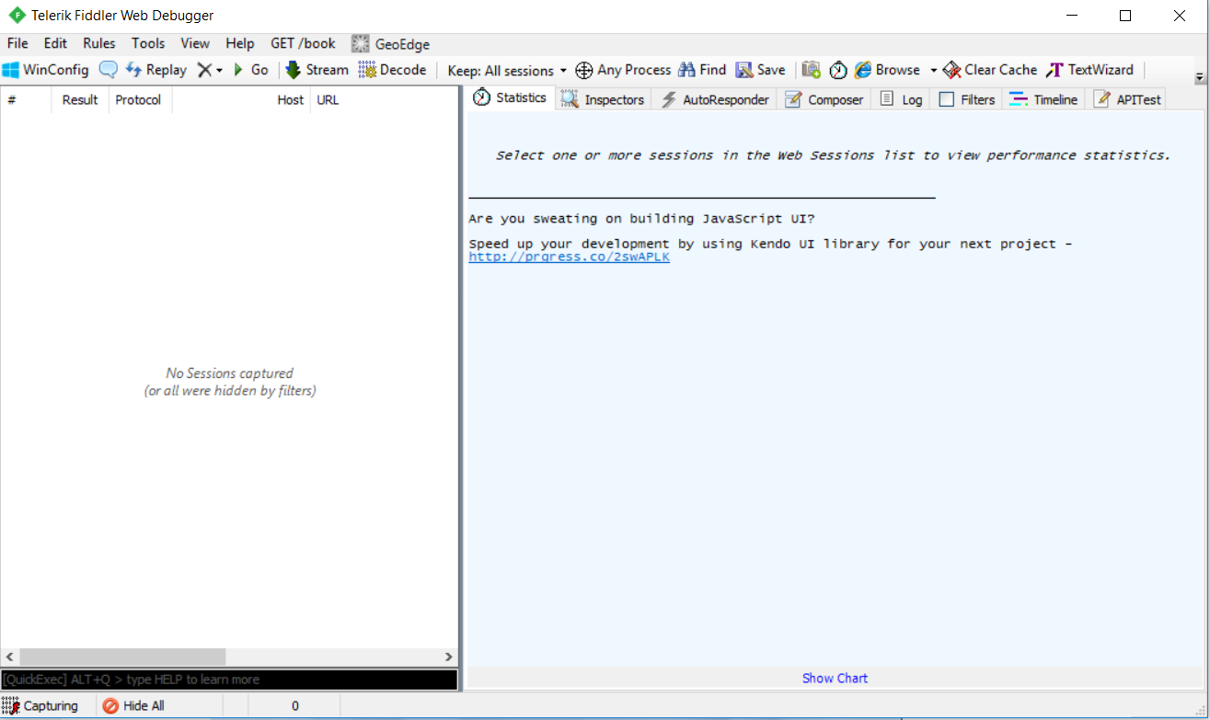

Fiddler by default captures all processes. But here we are not interested in all the processed, we are only interested in capturing our local processes i.e. capturing the WEB API HTTP Resources. So, click on the **All Processes button** which is at the bottom left corner and select **Hide All as shown in the below image**. Keep the focus on the Highlighted section.

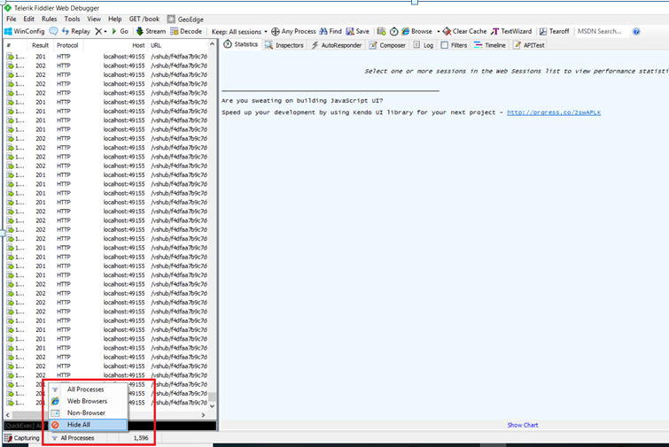

**Step3:**

In the next step, we need to click on the Composer tab. The first tab in the Composer tab is Parsed tab where we can configure the HTTP requests and execute it. The first drop-down includes all HTTP Methods. Select a particular HTTP method for the request you want to execute. Here, we will select the GET HTTP verb to execute HTTP GET request as shown below.

Please keep Focus on the selected section which is in Red Rectangle.

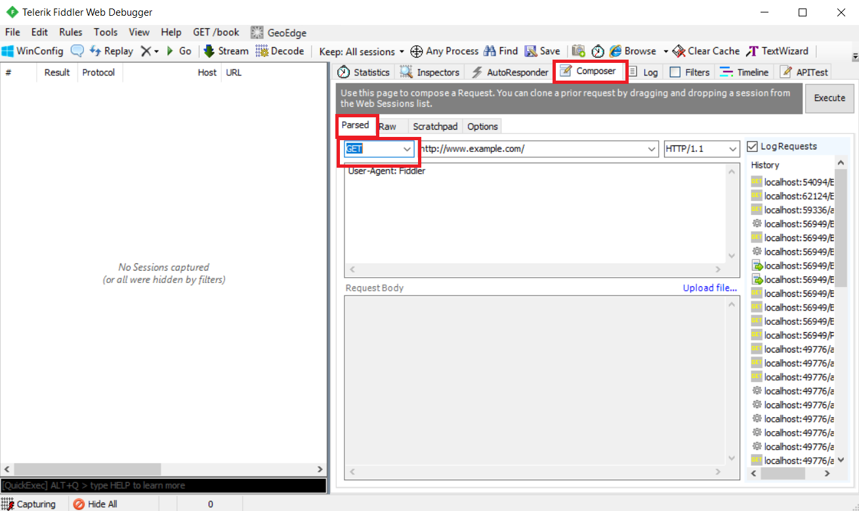

Now run the web API application and figure out the URL.

**Enter URL and Execute:**Now, we need to enter the URL of a request in the adjacent text box. Here, we will execute the HTTP request **http://localhost:xxxx/api/values** to the Web API which we created in the previous article as shown below.

**Note:** You need to change the **PORT Number**. Please Keep Focus on the Highlighted section.

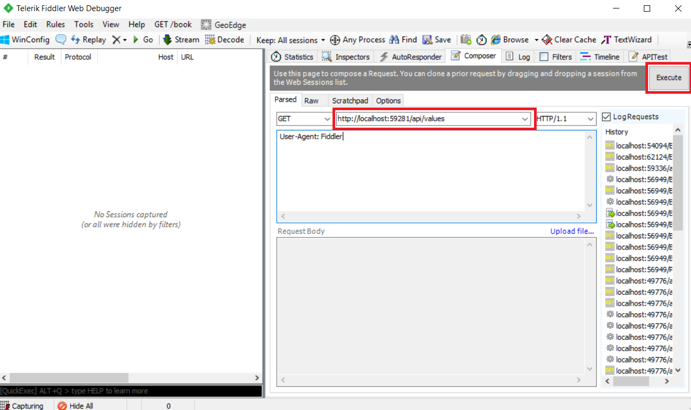

**Response in Fiddler:**

Once you enter the URL, click on the Execute button to send this HTTP request and it will immediately display the response in the left pane as shown in the below image.

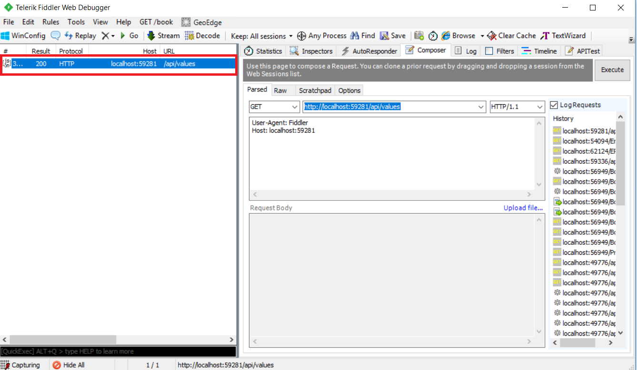

**Understanding Fiddler Request and Response:**

Double click on the result row above (which is highlighted with the red rectangle) to open the Inspector tab for the request as shown below.

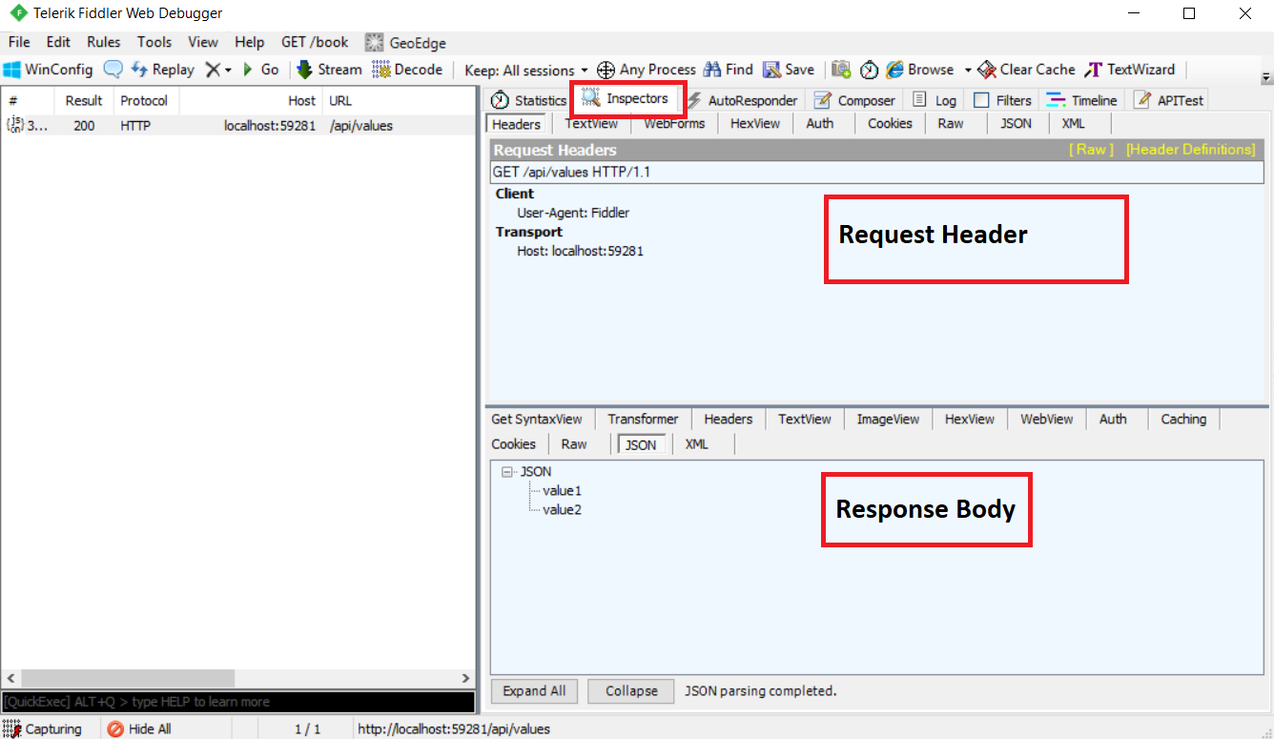

As you can see in the above image, the top panel shows the Request header and the bottom panel shows the response body.

**Fiddler Request & Response in Raw Format:**

You can also see the raw request header and response body by clicking on the Raw tab of request and response as shown in the image below.

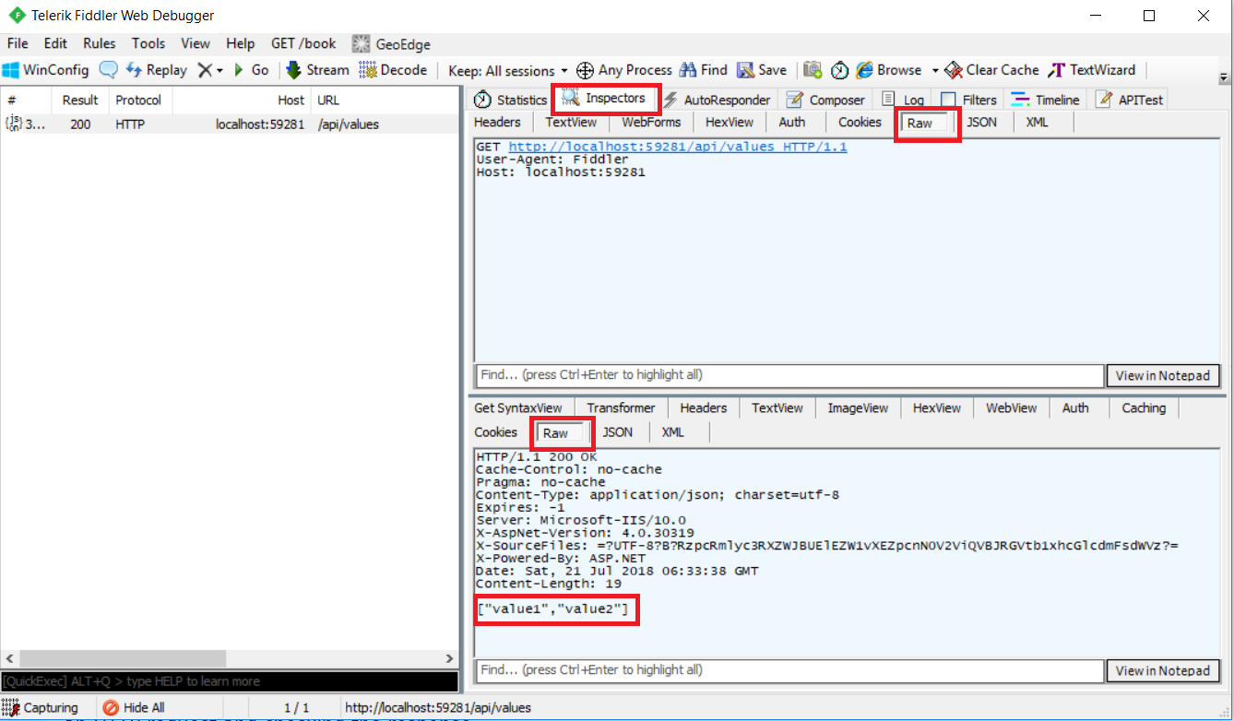

This is the most preferable way in Fiddler to execute an HTTP request and checking the response. Let’s see how to make a post request using Fiddler.

**Testing POST Request using Fiddler:**

1. Select the Compose Tab,
2. Then choose the HTTP verb as POST
3. Set the Content-Type as application/JSON.
4. In the request body, provide the string value that you want to add into the string array.
5. Click on the Execute button as shown below.

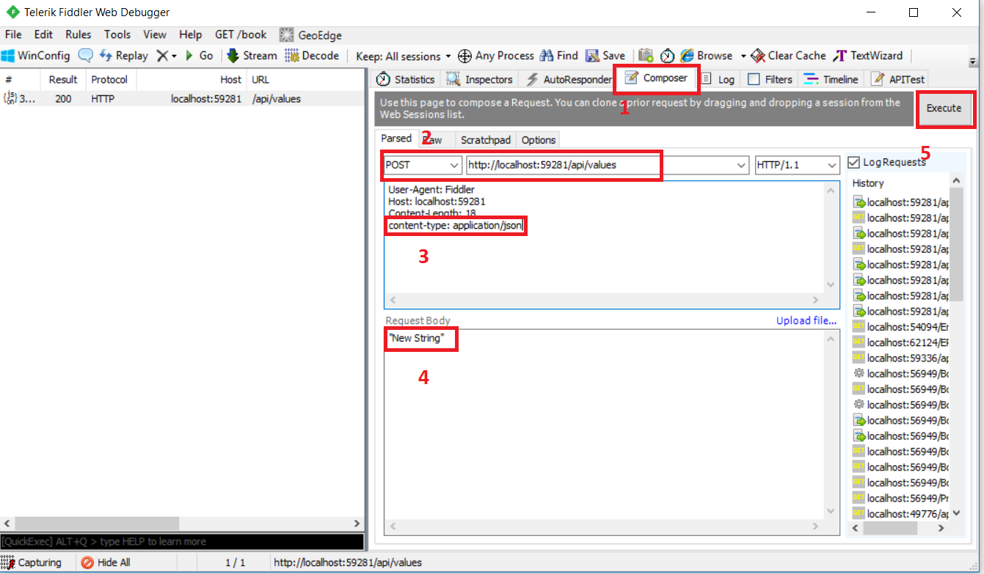

**Testing PUT Request using Fiddler:**

1. Select the Compose Tab,
2. Then choose the HTTP verb as PUT
3. In the URL provide the index of the array element whose value you want to update.
4. Set the Content-Type as application/json.
5. In the Request body, provide the updated string value that you want to update into the string array.
6. Finally, click on the Execute button as shown below.

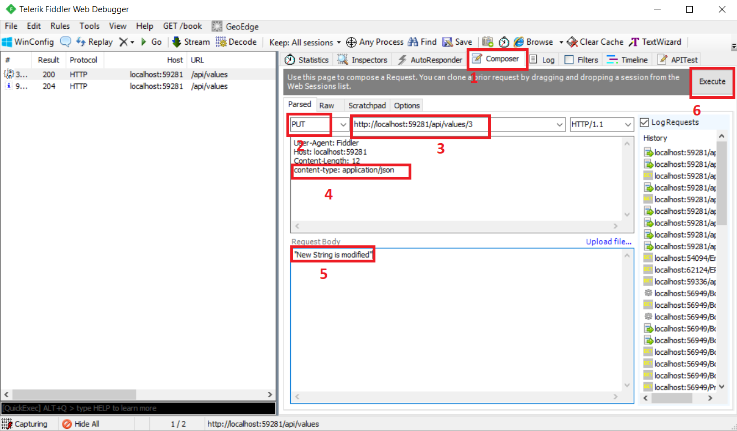

**Testing DELETE Request using Fiddler:**

1. Select the Compose Tab,
2. Then choose the HTTP verb as DELETE
3. In the URL provide the index of the array element whose value you want to update.
4. Finally, click on the Execute button as shown below.

**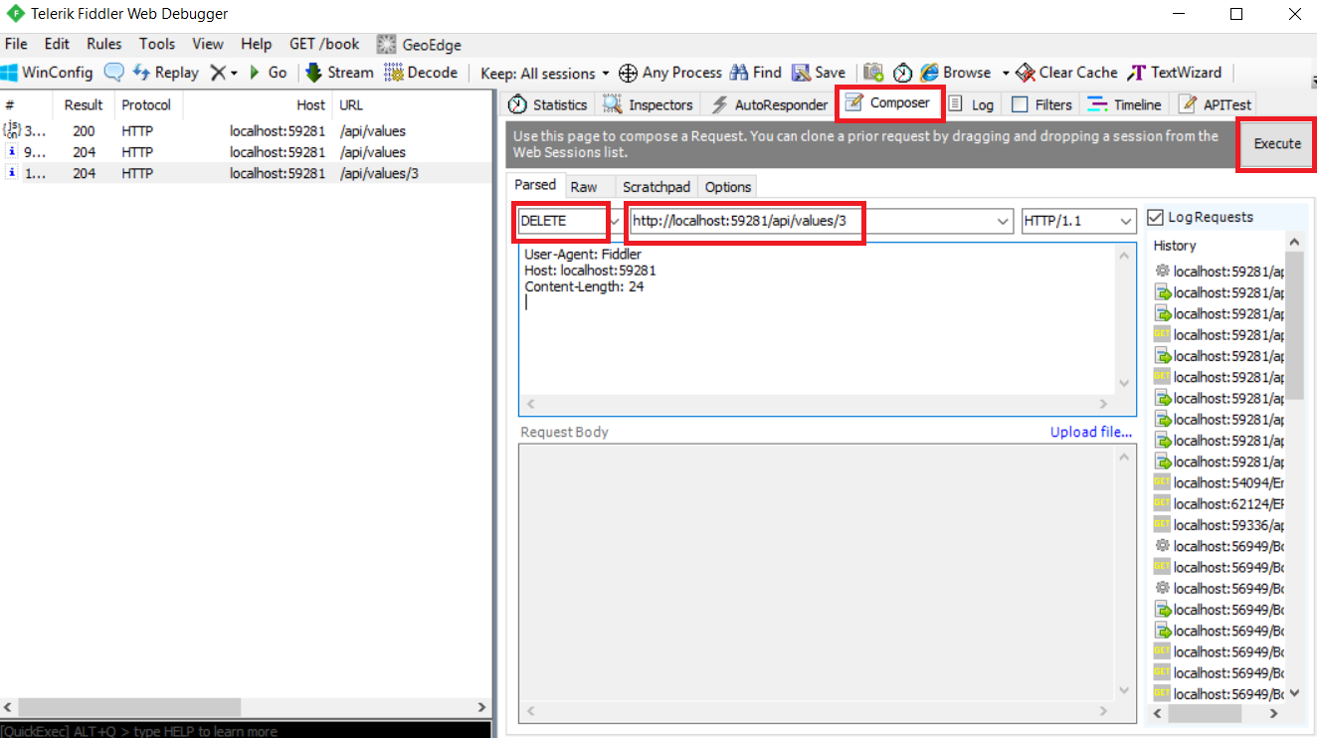**

**How to use POSTMAN to test Web API**

1. **What is Postman?**
2. **How to download and Install Postman?**
3. **How to test Web API Services using Postman?**
4. **Understanding the Request and Response of Postman.**
5. **How to use Postman to test Get, Post, Put and Delete Request?**

**What is POSTMAN?**

The Postman is the most popular and the most powerful HTTP client for testing the restful web services. Postman makes it easy to test the Restful Web APIs, as well as it develops and documents Restful APIs by allowing the users to quickly put together both simple and complex HTTP requests. The Postman is available as both a Google Chrome in-browser app and Google Chrome Packaged App.

The packaged app version of Postman provides many advanced features that include**OAuth 2.0** support and **bulk uploading/importing** that are not available with the Google Chrome in-browser app version. The in-browser version includes a few features, such as session cookies support, that are not yet available in the packaged app version.

Let’s see how to use POSTMAN to send an HTTP request to our local ASP.NET Web API Services and check the response.

**Step 1:**Download and install POSTMAN from [Postman](https://chrome.google.com/webstore/detail/postman/fhbjgbiflinjbdggehcddcbncdddomop?hl=en)

**Step 2:**Once the Postman is successfully installed, open the Postman. It will look like the image shown below.

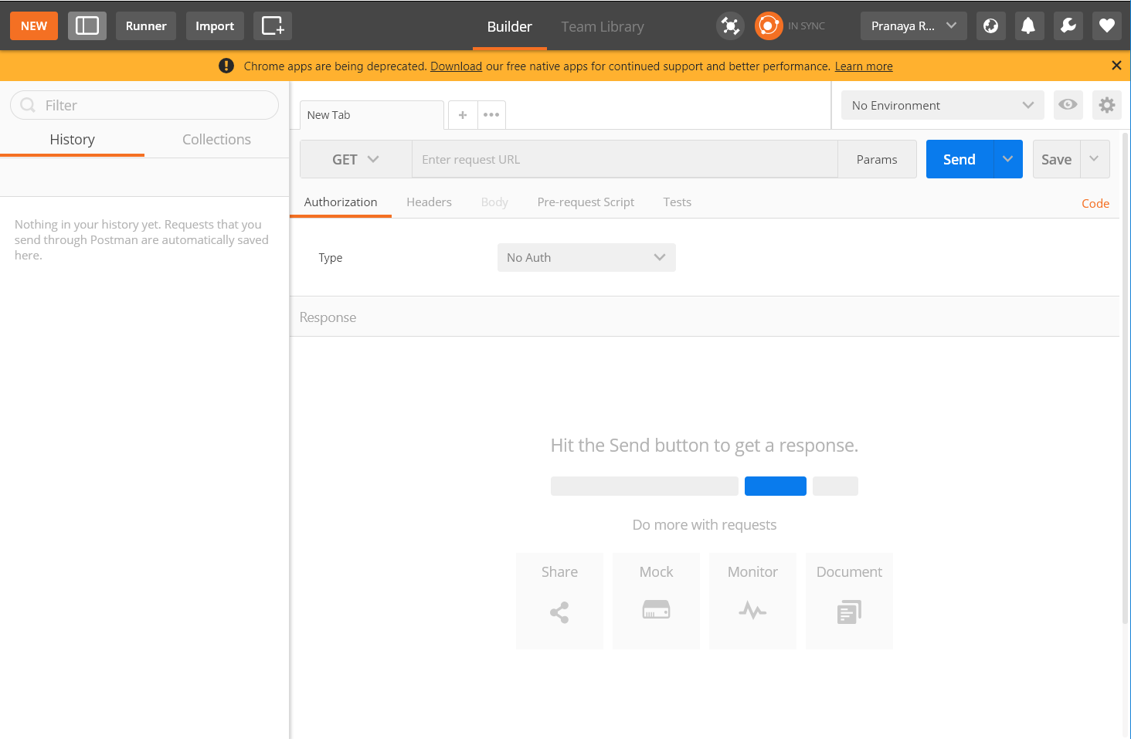

**GET Request using Postman:**

Select the HTTP Method as “GET” and enter the URL of your Web API as shown in the below image.

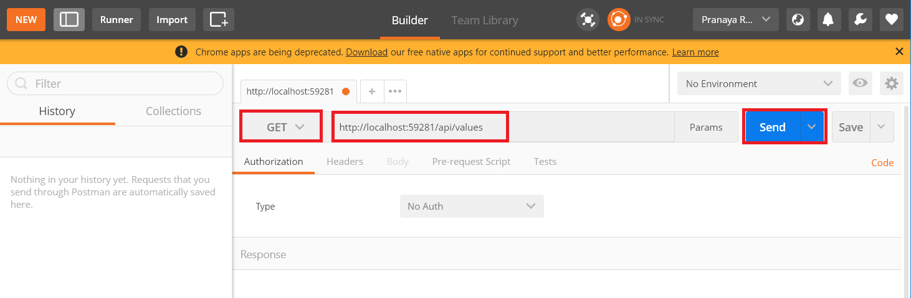

Once you click on the Send button, an HTTP request is sent to the provided URL. The response coming from the Web API Server is displayed in the below image.

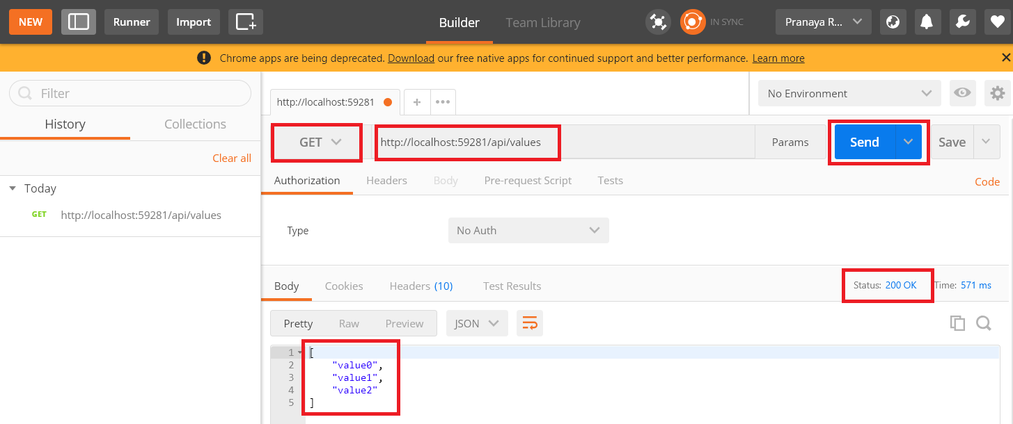

As you can see in the above image, the HTTP response shows data and response status. Thus, you can also use Postman to test your Web API.

**POST Request using Postman:**

1. Choose the HTTP verb as **POST**
2. Set the URL
3. Set the Content-Type as **application/json**. To do this click on the Header tab and provide the key value as shown in the below image

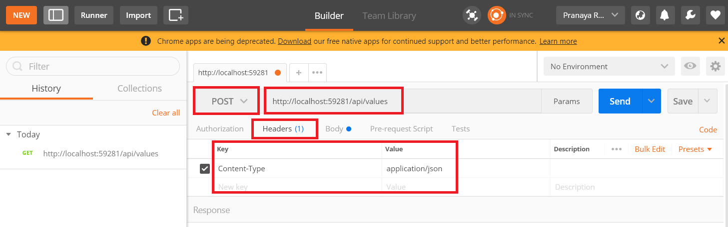

Next, we need to provide the string value that we want to add to the string array. We need to provide string value in the request body. To do so click on the body tab and provide the string value as shown below.

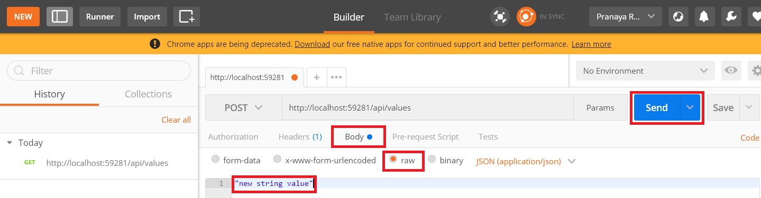

Once you provided the string value in the request body, click on the send button which will issue a post request to the web API. In the same way, you can test the PUT and DELETE Requests. In this article series, we are going to use the tool [**Fiddler**](https://dotnettutorials.net/lesson/how-to-use-swagger-in-web-api/)and [**Postman**](https://dotnettutorials.net/lesson/how-to-use-postman-to-test-web-api/)to test the services.

**ASP.NET Web API using SQL Server**

**Creating the Required Database:**

We are going to use the following Employees table in this demo to understand how to create Web API service using SQL Server database.

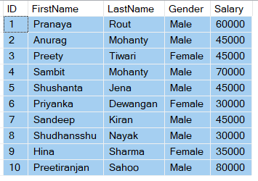

Please use the following SQL Script to create and populate the Employees table with some test data. The below SQL script

1. Create a database called WEBAPI\_DB
2. Then creates the Employees table and populate it with some test data

**CREATE** **DATABASE** WEBAPI\_DB

**GO**

**USE** WEBAPI\_DB

**GO**

**CREATE** **TABLE** Employees

(

**ID** int primary key identity,

FirstName nvarchar(50),

LastName nvarchar(50),

Gender nvarchar(50),

Salary int

)

**GO**

**INSERT** **INTO** Employees **VALUES** ('Pranaya', 'Rout', 'Male', 60000)

**INSERT** **INTO** Employees **VALUES** ('Anurag', 'Mohanty', 'Male', 45000)

**INSERT** **INTO** Employees **VALUES** ('Preety', 'Tiwari', 'Female', 45000)

**INSERT** **INTO** Employees **VALUES** ('Sambit', 'Mohanty', 'Male', 70000)

**INSERT** **INTO** Employees **VALUES** ('Shushanta', 'Jena', 'Male', 45000)

**INSERT** **INTO** Employees **VALUES** ('Priyanka', 'Dewangan', 'Female', 30000)

**INSERT** **INTO** Employees **VALUES** ('Sandeep', 'Kiran', 'Male', 45000)

**INSERT** **INTO** Employees **VALUES**('Shudhansshu', 'Nayak', 'Male', 30000)

**INSERT** **INTO** Employees **VALUES** ('Hina', 'Sharma', 'Female', 35000)

**INSERT** **INTO** Employees **VALUES** ('Preetiranjan', 'Sahoo', 'Male', 80000)

**GO**

**Creating a new ASP.NET Web API Project**

Open Visual Studio and select**File – New – Project** as shown below

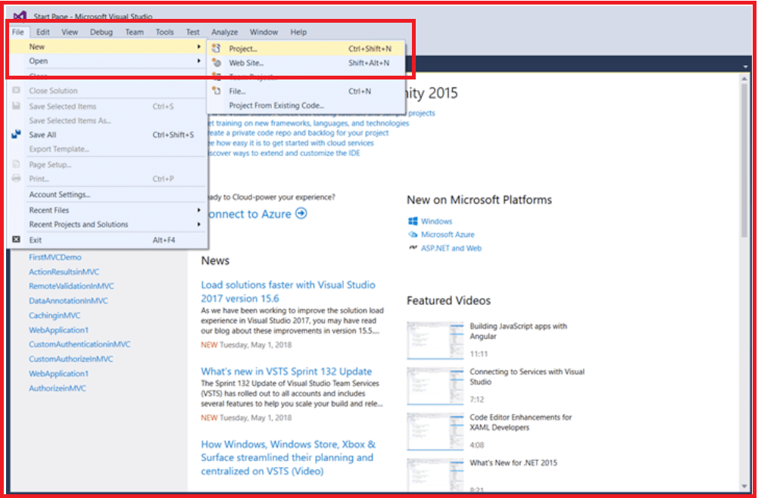

From the “New Project” window, Select “**Visual C#**” under the “**Installed – Templates**” section. Again from the middle pane, you need to select the “**ASP.NET Web Application”** and name the project as “**EmployeeService**“. Finally, click on the “**OK**” button as shown in the below image.

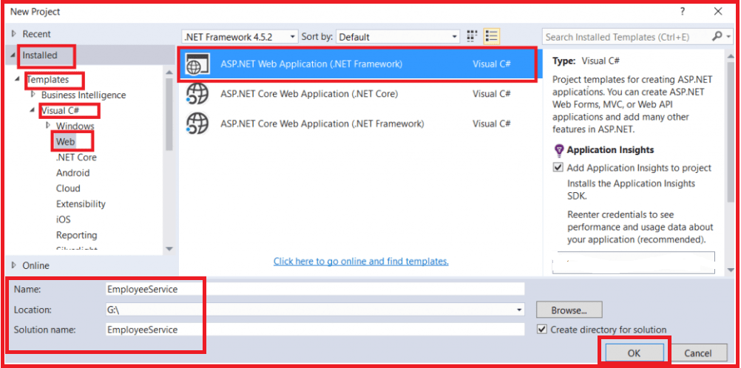

Once you click on the **OK** button. A new dialog window will open with Name “**New ASP.NET Project**” for selecting project Templates as per your requirement.

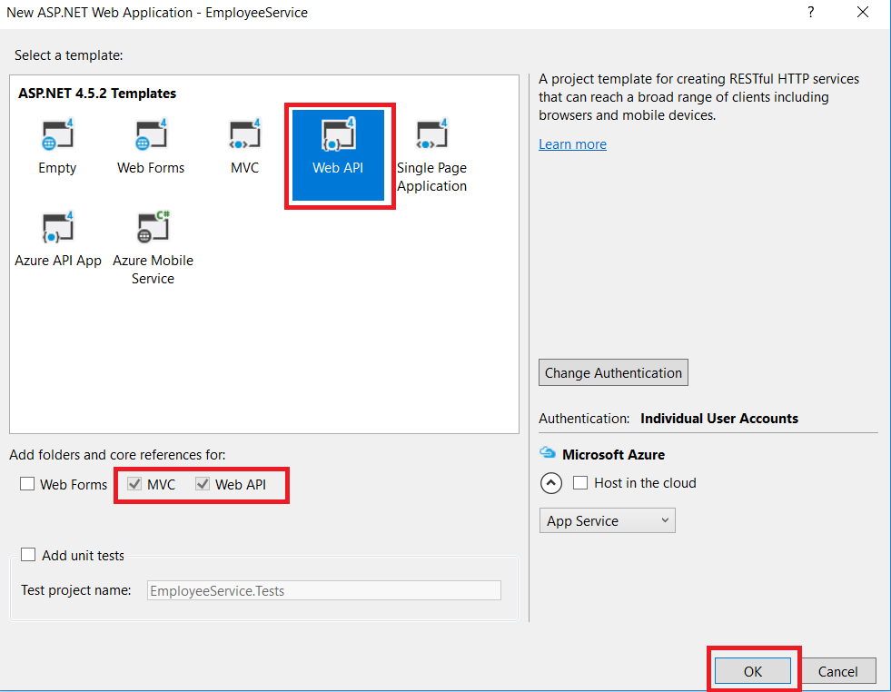

In this dialog, we are going to choose WEB API project template and click on the OK Button. At this point, you should have the Web API project created with the following structure.

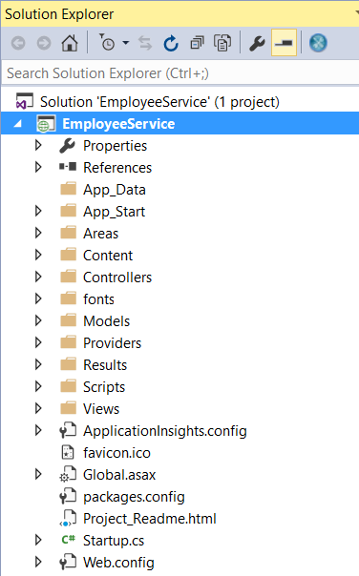

**Adding ADO.NET Entity Data Model to retrieve data from the database**

Right-click on the Models folder and then select **Add – New Item**and from the “**Add New Item**” window select “**Data**” from the left pane and then select**ADO.NET Entity Data Model** from the middle pane

In the Name text box, type **EmployeeDataModel** and click on the **Add**button as shown in the below image.

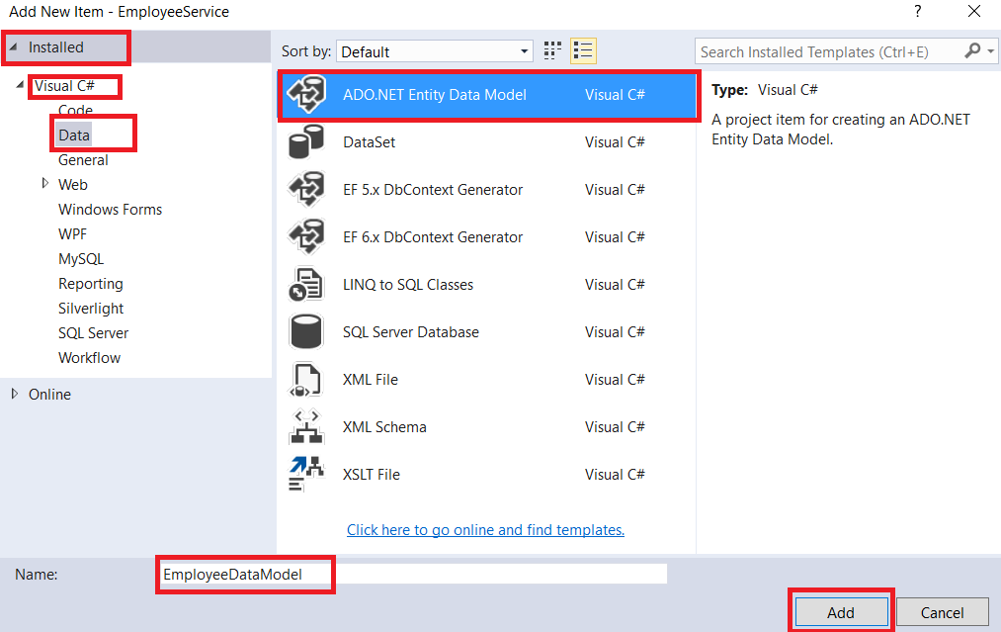

On the Entity Data Model Wizard, select “**EF Designer from database**” option and click **next**

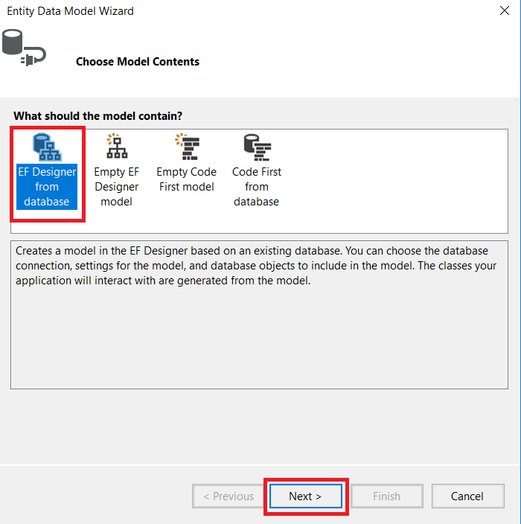

On the next screen, click on the “**New Connection**” button as shown in the image below

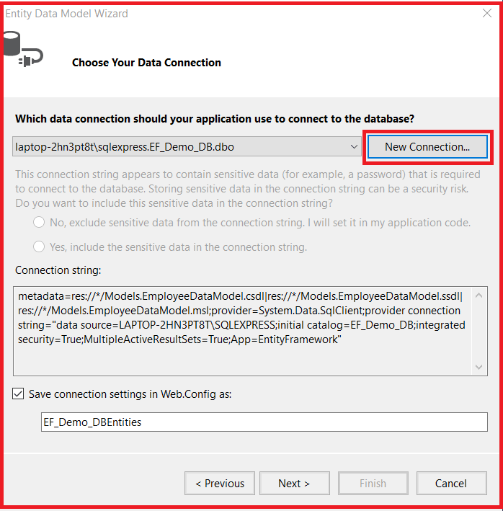

Once you click on the New Connection Button it will open the Connection Properties window.

On “**Connection Properties**” window, set

1. Server Name = provide the server
2. Authentication = Select the authentication type
3. Select or enter a database name = WEBAPI\_DB

    Finally, click on the **OK** button as shown below.

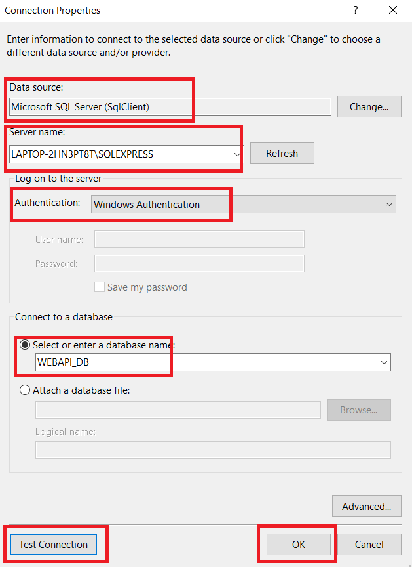

Once you click on the OK button it will navigate back to the Choose Your Data Connection wizard. Here Modify the Connection String as **EmployeeDBContext** and click on the **Next** Button as shown in the below image.

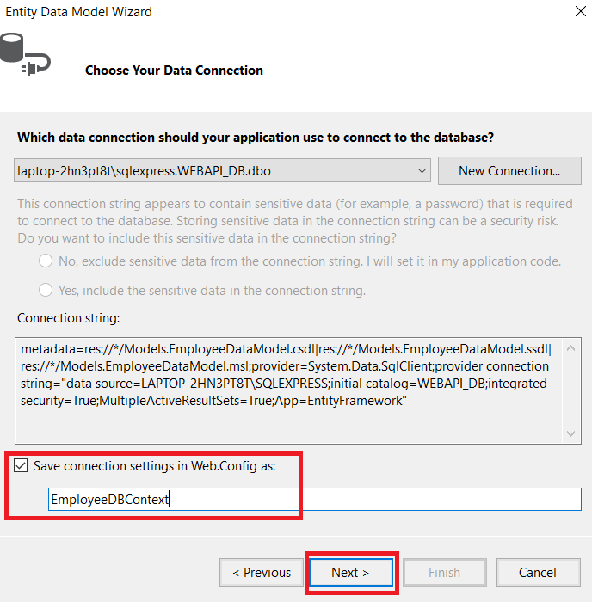

On the next screen, select Entity Framework 6.x as shown in the below image. This step may be optional if you are using a higher version of visual studio.

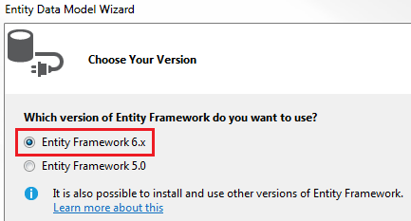

On Choose Your Database Objects and Settings screen, select the “**Employees**” table, provide the model namespace name and click on the Finish button as shown below.

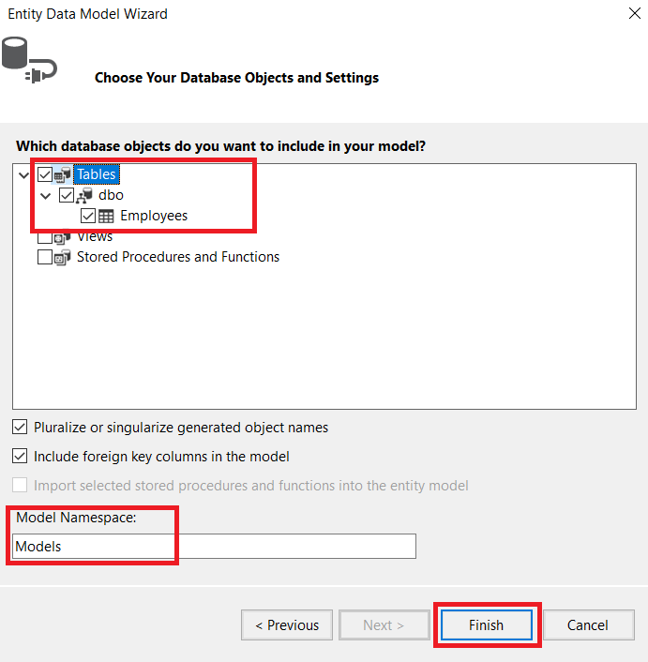

Once you click on the Finish Button the following edmx file will generate.

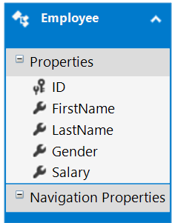

The edmx file is generated within the Models folder as shown below.

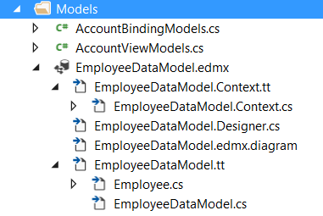

**Adding Web API Controller**

1. Right click on the Controllers folder in **EmployeeService** project and select **Add – Controller**

2. Then you need to select the “**Web API 2 Controller – Empty**” and then click on the “**Add**” button as shown in the below image.

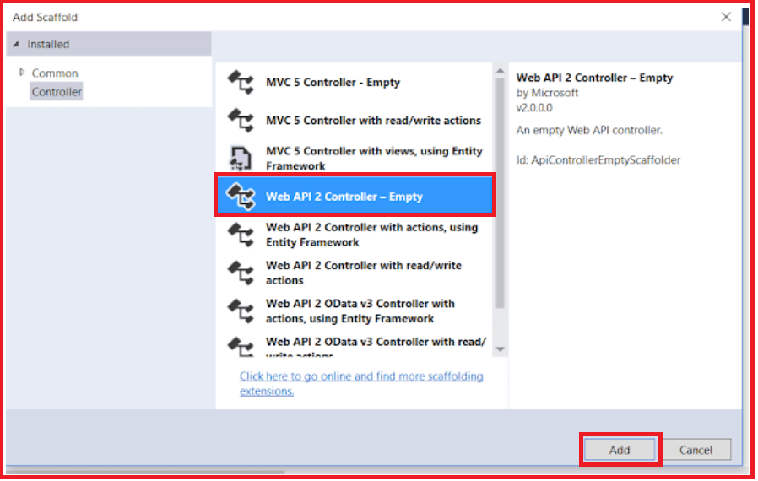

On the next screen set, the Controller Name as **EmployeesController** and click on the **Add** button as shown in the below image.

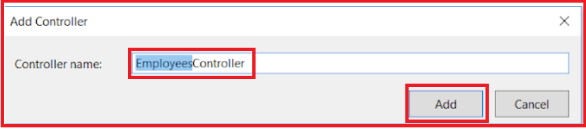

**Copy and paste the following code in EmployeesController.cs**

**namespace** *EmployeeService.Controllers*

**{**

**public** **class** EmployeesController : ApiController

**{**

**public** IEnumerable**<**Employee**>** Get**()**

**{**

**using** **(**EmployeeDBContext dbContext = new EmployeeDBContext**())**

**{**

**return** dbContext.Employees.ToList**()**;

**}**

**}**

**public** Employee Get**(int** id**)**

**{**

**using** **(**EmployeeDBContext dbContext = new EmployeeDBContext**())**

**{**

**return** dbContext.Employees.FirstOrDefault**(**e =**>** e.ID == id**)**;

**}**

**}**

**}**

**}**

Please import the below namespace.

**using EmployeeService.Models;**

At this point when we navigate to /**api**/**employees** we should see all employees and when we navigate to **/api/employees/1** we should see all the details of the employee whose Id=1

**Content Negotiation in Web API**

1. **What is Content Negotiation and it’s needed in Rest Services?**
2. **How does the Web API Framework know in which format the client expects the response?**
3. **Understanding the Accept and Content-Type headers in a request.**
4. **Example to implement Content Negotiation in ASP.NET Web API Application.**
5. **How to request data in JSON Format?**
6. **How to request data in XML Format?**
7. **What does the Web API Framework do when we request for data in a specific format?**

**What is Content Negotiation and it’s needed in Rest Services?**

We know that there are three pillars of the internet and they are:

1. The resource
2. The URL
3. The representation

The first two are (i.e. the resource and the URL) very straightforward but the last one (i.e. the representation) is a little confusing to understand. The representation is very important in the modern web. Why? Because people are currently not only using Desktop computers to browse the web, but they also are using various types of devices (tab, mobile, etc.) to consume web applications. And the important and the interesting fact is that all these various devices expect the data in various formats.

For example, a few clients want the data in normal HTML while some of them want the data in a normal text format. Others may need the data in JSON format and still some other wants the data in XML format.

**Content Negotiation Definition:**

We can define Content Negotiation as “**the process of selecting the best representation for a given response when there are multiple representations available**”.

One of the standards of the REST service is that **the client should have the ability to decide in which format they want the response – whether they want the response in XML or JSON etc**. This is called Content Negotiation.

Now, the fact should be clear that “**Web API Content Negotiation**” means the client and server can negotiate. Always It is not possible to return data in the requested format by the Server. That’s why it is called negotiation, not demand. In such cases, the Web API Server will return the data in the default format.

**How does the Web API Framework know in which format the client wants the response?**

This is done by checking the below headers of the request object.

1. **Content-type:** The content-type header value request to the Web API Server to represent data in this format. The values for Content-type includes “**application/json**“, “**application/xml**“, etc.
2. **Accept:**The Accept header value specifies the media types which are acceptable for the response, such as “**application/json**” and “**application/xml**” or any other custom media type such as “**application/vnd.dotnettutorials.employees+xml**“.
3. **Accept-Charset:**The **Accept-Charset** header specifies which character sets are acceptable, such as **UTF-8** or **ISO 8859-1.**
4. **Accept-Encoding:**The **Accept-Encoding** header specifies which content encodings are acceptable, such as **gzip**.
5. **Accept-Language:**The **Accept-Language**header specifies the preferred natural language support, such as “**en-us**“.

**Understanding the Accept and Content-Type headers:**

A request that is sent to the server includes Accept and Content-Type headers. Using the Accept header the client can specify the format for the response. For example

**Content-Type: application/xml**returns XML  
**Content-Type: application/json** returns JSON  
**Accept: application/xml**returns XML  
**Accept: application/json** returns JSON

Depending on the Accept header and Content-Type value in the request object, the server sends the response. This is called Web API Content Negotiation.

**Example to understand Content Negotiation in ASP.NET Web API.**

In this article, we are going to work with the same example that we started in our previous article where we discussed the step by step procedure of [**working with SQL Server**](https://dotnettutorials.net/lesson/web-api-with-sql-server/).

**Below is our controller**

**namespace** *EmployeeService.Controllers*

**{**

**public** **class** EmployeesController : ApiController

**{**

**public** IEnumerable**<**Employee**>** Get**()**

**{**

**using** **(**EmployeeDBContext dbContext = new EmployeeDBContext**())**

**{**

**return** dbContext.Employees.ToList**()**;

**}**

**}**

**public** Employee Get**(int** id**)**

**{**

**using** **(**EmployeeDBContext dbContext = new EmployeeDBContext**())**

**{**

**return** dbContext.Employees.FirstOrDefault**(**e =**>** e.ID == id**)**;

**}**

**}**

**}**

**}**

**How to Request Web API Service to Return Data in JSON Format?**

The JSON format is currently the most popular format of data representation. So, first, we will see how to return the data in JSON format from the Web API. We are using a tool called Fiddler to test the API services. So please read [how to use Fiddler to test the web API tutorial](https://dotnettutorials.net/lesson/how-to-use-fiddler-to-test-web-api/) before proceeding to this article.

Here is our HTTP header information to get the employee details whose id is 1. Select the Compose Tab. Then select the HTTP verb as “GET”. Then provide the URL and click on the Execute button as shown in the below image.

**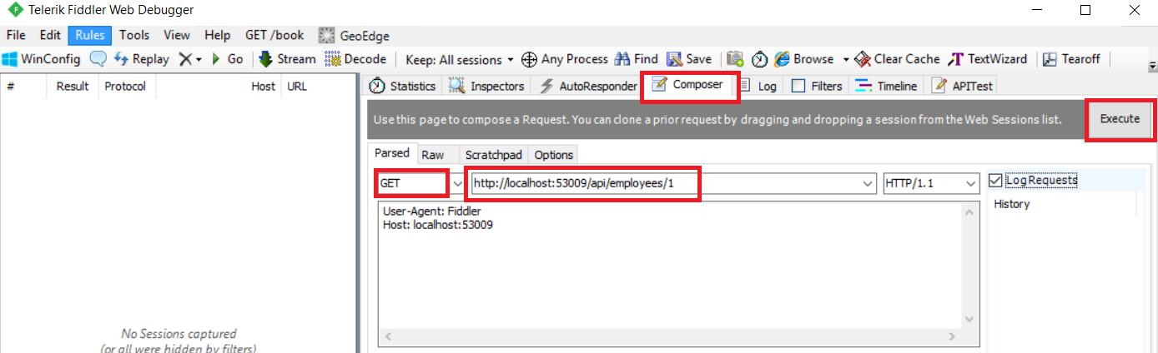**

Here you can see that we did not set the **Content-Type** header value to request the data in **JSON** format but the Web API returning the data in **JSON** format. The reason is by default the Web API will return the data in **JSON** format if we do not specify any “**Content-Type**” header in the request. See the following output.

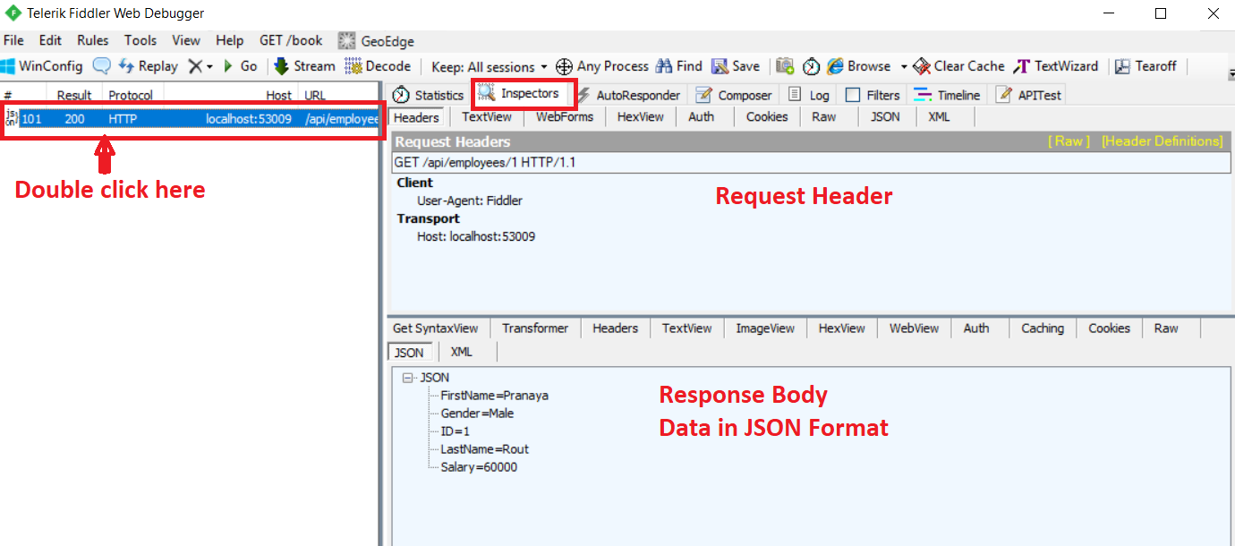

And obviously, we can also modify the header value like the following to get the data in **JSON** format.

**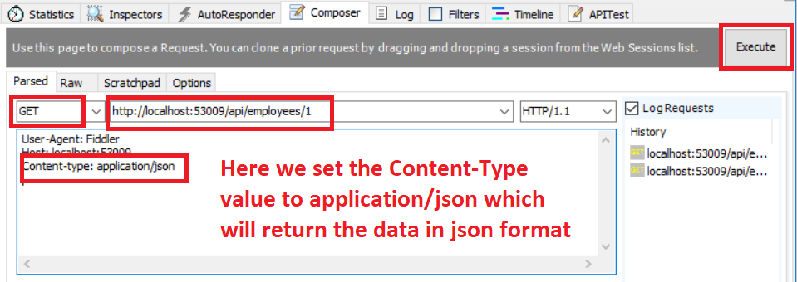**

Both requests will give us the same output in reality.

**How to Request Web API Server to return the data in XML format?**

In this example, we will request the Web API to return the data in XML format. When the application used SOAP-based messages (it’s not that SOAP is obsolete in modern applications, it’s still there but people like to use smarter JSON rather than too much informative and stuffy XML).

Now to get the data in XML format we need to set the Content-Type header of the Http Request to application/xml as shown below.

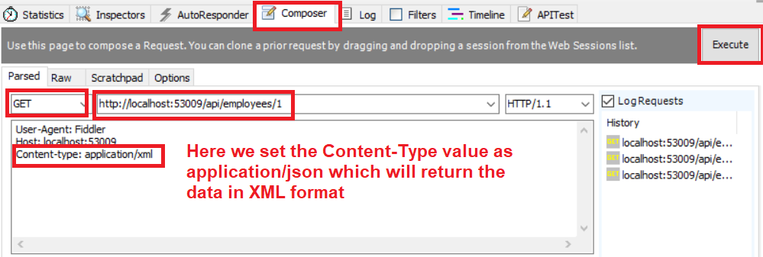

Once you click on the execute button, you will get the data in XML format as shown in the below image.

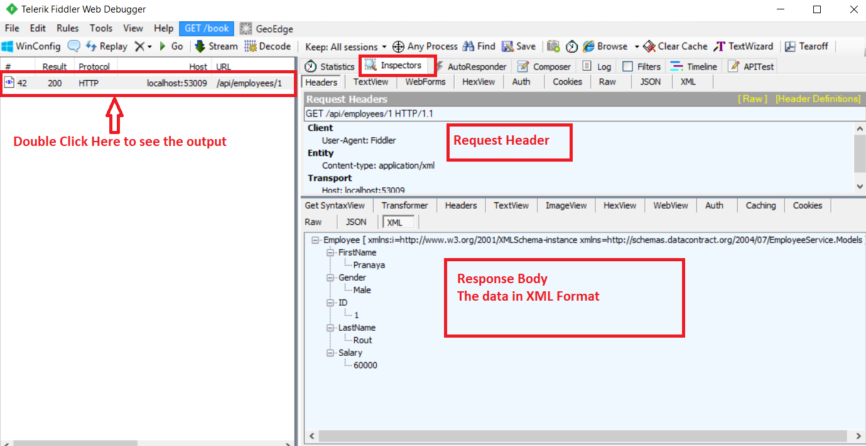

The above two are the formats (i.e. JSON and XML) that the Web API supports by default. If you want other than these two types of representations then you need to implement a media type formatter in the Web API.

**Understanding Accept Header in Http Request:**

In our previous examples, we saw how a content-type header works with Http Request. In this example, we will understand the “**Accept**” header of the Http Request.

By checking the “Accept” header value, the Web API understands which represents the client is able to accept. For example, if we specify that the client can understand the following representations: **application/xml , application/json, text/javascript**Then the Web API will return the data in JSON format, the reason is JSON is the default format of the Web API, although the client’s first preference is the XML format. We will prove it with a small example. Have a look at the following screen.

**Request With Accept Header:**

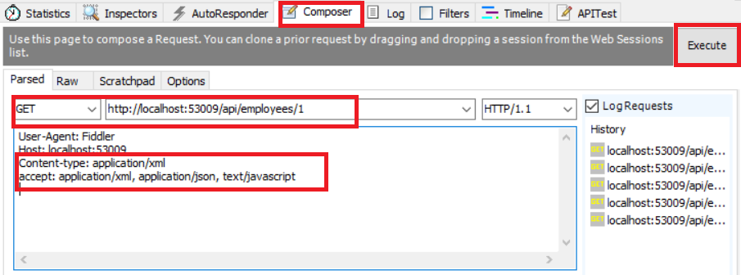

**And the output will be**

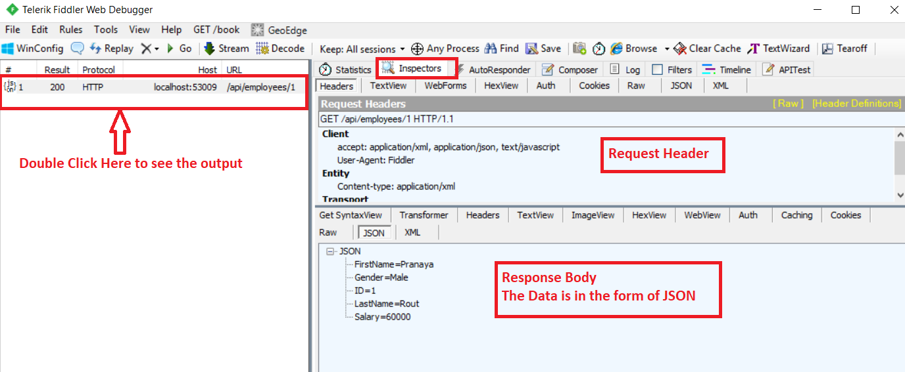

**Understanding Accept-Language header**

In the **Accept-Language** header, we can specify the preferred language that we want to get from the Web API application. The **Accept-Language** header is used as **Accept-Language: en-IN, en-US**

The above Accept-Language header indicates that my first choice of language is Indian English but if that is not possible then please give me US English and if that is not possible then please provide the data in the default language.

So Web API Content negotiation is a mechanism, or algorithm, used to determine, based on the client’s request, which media type formatter is going to be used to return an API response. In the next article, we will discuss [**what is media type**](https://dotnettutorials.net/lesson/media-type-formatters-web-api/)formatter and how it works with some examples.

**What does the Web API Framework do when we request data in a specific format?**

The controller in Web API first generates the data that we want to send to the client. For example, if we have asked for the list of employees. The Web API Controller generates the list of employees, and hands the data to the Web API pipeline which then looks at the **Accept header** value, and depending on the format that the client has requested, the **Web API** will choose the appropriate formatter. For example, if the client has requested the data in XML format, then Web API uses XML Formatter. similarly, if the client has requested the data in JSON format, then Web API uses JSON Formatter. These formatters are called **Media Type Formatters**.

ASP.NET Web API is greatly extensible. This means we can also plug in our own formatters, for custom formatting the data. Multiple values can also be specified for the Accept header. In this case, the server picks the first formatter which is a JSON formatter, and formats the data in JSON.

**Accept: application/xml,application/json**

You can also specify a quality factor. In the example below, XML has a higher quality factor than JSON, so the server uses XML formatter and formats the data in XML.

**application/xml;q=0.8,application/json;q=0.5**

If you don’t specify the Accept header in the request then by default the Web API returns the data in JSON format.

When the response is sent to the client, notice that the **Content-Type** header of the response is set to the appropriate value. For example, if the client has requested for application/xml, then the server sends the data in XML format and also sets the **Content-Type=application/xml**.

**Role of Media Type Formatter:**

The Web API uses the formatters for both request and response messages. When the client makes a request to the server, the client has to set the **Content-Type** header to the appropriate value to let the server know the format of the data that we are sending. For example, if the client is sending JSON data, the Content-Type header is set to application/json. The server knows it is dealing with JSON data, so it uses JSON formatter to convert JSON data to .NET Type. Similarly, when a response is being sent from the server to the client, depending on the Accept header value, the appropriate formatter is used to convert the .NET type to JSON, XML, etc.

We can also very easily change the serialization settings of these formatters. For example, if we want the JSON data to be properly indented and use a camel case instead of a Pascal case for property names, all we have to do is modify the serialization settings of JSON formatters as shown below. With our example, this code goes in WebApiConfig.cs file in the App\_Start folder.

**config.Formatters.JsonFormatter.SerializerSettings.Formatting = Newtonsoft.Json.Formatting.Indented;**  
**config.Formatters.JsonFormatter.SerializerSettings.ContractResolver= new CamelCasePropertyNamesContractResolver();**

**Media Type Formatter in Web API**

1. **What are MediaTypeFormatters in Web API?**
2. **How to retrieve the Built-in Media Type Formatters in ASP.NET Web API?**
3. **Example of Media Type Formatters.**
4. **Understanding MediaTypeFormatter classes in ASP.NET Web API?**
5. **How to return the data in JSON format from Web API Service irrespective of the Accept header value?**
6. **How to return the data in XML format from Web API Service irrespective of the Accept header value?**
7. **Return JSON instead of XML from ASP.NET Web API Service when a request is made from the browser?**

**Note:** We are going to work with the same example that we started in [**ASP.NET Web API using the SQL Server**](https://dotnettutorials.net/lesson/web-api-with-sql-server/) article. So please read that article before proceeding to this article.

**What are MediaTypeFormatters in Web API?**

As we have seen in the previous article that the Web API handles the JSON and XML formats data based on the Accept and Content-Type headers. But, the important question is how does it handle these different formats? The answer is: **By using Media-Type formatters**.

The Media type formatters are the classes that are responsible for serializing the request/response data so that the Web API Framework can understand the request data format and also send data in the format which the client expects. ASP.NET Web API includes the following built-in media type formatters.

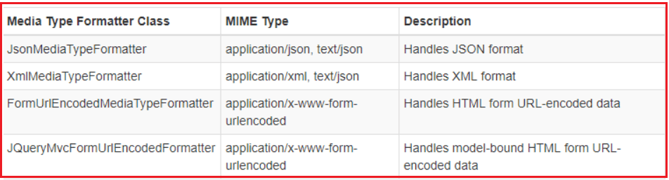

**How to Retrieve the Built-in Media Type Formatters in ASP.NET Web API?**

The Web API Framework includes the above-listed media type formatter classes by default. However, you can also add, remove or change the order of the formatters. The following example demonstrates an HTTP Get method that returns all built-in formatter classes.

**public** IEnumerable**<**string**>** Get**()**

**{**

IList**<**string**>** formatters = new List**<**string**>()**;

**foreach** **(**var item in GlobalConfiguration.Configuration.Formatters**)**

**{**

formatters.Add**(**item.ToString**())**;

**}**

**return** formatters.AsEnumerable**<**string**>()**;

**}**

In the above example, the **GlobalConfiguration.Configuration.Formatters** returns the **MediaTypeFormatterCollection** that includes all the formatter classes. The above example returns the names of all the formatter classes as shown in the image below.

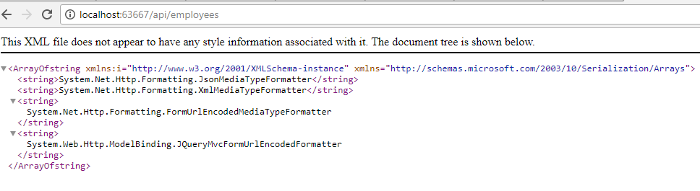

Alternatively, the **MediaTypeFormatterCollection** class defines convenience properties that provide direct access to three of the four built-in media type formatters. The following example shows retrieving the media type formatters using MediaTypeFormatterCollection’s properties.

**public** IEnumerable**<**string**>** Get**()**

**{**

IList**<**string**>** formatters = new List**<**string**>()**;

formatters.Add**(**GlobalConfiguration.Configuration.Formatters.JsonFormatter.GetType**()**.FullName**)**;

formatters.Add**(**GlobalConfiguration.Configuration.Formatters.XmlFormatter.GetType**()**.FullName**)**;

formatters.Add**(**GlobalConfiguration.Configuration.Formatters.FormUrlEncodedFormatter.GetType**()**.FullName**)**;

**return** formatters.AsEnumerable**<**string**>()**;

**}**

The above example returns the following response to the browser.

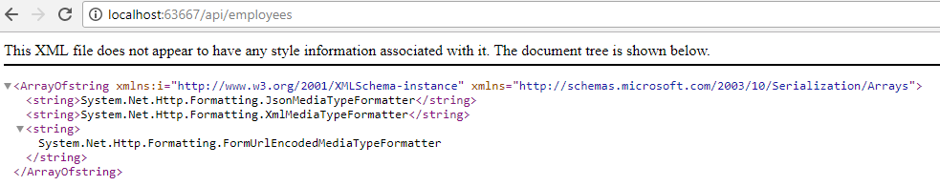

**Understanding Media Type Formatters with an example**

From the ASP.NET Web API perspective, serialization is the process of translating a .NET Common Language Runtime (CLR) type into a format that can be transmitted over HTTP. The default format in Web API can be either JSON or XML. A media type formatter that is an object of type **MediaTypeFormatter**, performs the serialization in the ASP.NET Web API pipeline.

**Consider a simple action method handling GET in an ApiController:**

**public** Employee Get**(int** id**)**

**{**

**using** **(**EmployeeDBContext dbContext = new EmployeeDBContext**())**

**{**

**return** dbContext.Employees.FirstOrDefault**(**e =**>** e.ID == id**)**;

**}**

**}**

The above method returns a CLR object of Employee type. In order to return the data contained in the Employee object to the client, the Employee object needs to be serialized. The serialization in ASP.NET Web API application is generally performed by the **MediaTypeFormatter**.

The Web API Media Type Formatters serializes the object which is going to be returned from the action method into either JSON or XML. Once the Web API Media Type Formatters serializes the data into XML or JSON then these JSON or XML data written into the response message body.

The Web API media type formatters that serialize the object into the JSON and XML are JsonMediaTypeFormatter and XmlMediaTypeFormatter respectively. Both the classes are deriving from MediaTypeFormatter class. The process through which the MediaTypeFormatter is chosen is called [**content negotiation**](https://dotnettutorials.net/lesson/content-negotiation-web-api/) which we discussed in our previous article in detail.

**What is Web API MediaTypeFormatter?**

The Web API MediaTypeFormatter is an abstract class from which the **JsonMediaTypeFormatter**and **XmlMediaTypeFormatter**classes are inherited. **JsonMediaTypeFormatter** handles the JSON request and response where the XmlMediaTypeFormatter handles the XML request and response.

A resource can have one or more representations. When we issue a GET request to retrieve a resource, such as an employee with ID 1, the response message contains the representation of the resource, for example, any value that specific action returns. The Web API indicates how the resource is represented in the response through the Content-Type response header. The Accept request header can be used by a client to indicate the set of preferred representations for the resource in the response.

By default, the Web API framework supports two media types: JSON and XML. When you issue a request with **Accept: application/json**, then the response message will be JSON and the Content-Type will be set to **application/json**. Similarly, if you issue a request with **Accept: application/xml**, then the response message will be XML and the Content-Type will be set to **application/xml**.

You can also specify a quality value indicating the relative preference. The range is 0–1, with 0 being unacceptable and 1 being the most preferred. The default value is 1. For example, consider the below header

**Accept: application/json; q=0.8, application/xml;q=0.9**

Here, the response message will be in XML format because the **application/xml** has a quality value of 0.9, which is higher than the quality value of 0.8 specified for **application/json**.

**How to return the data in JSON format from Web API Service irrespective of the Accept header value?**

Include the following line in Register() method of WebApiConfig.cs file in the App\_Start folder. This line of code completely removes XmlFormatter which forces ASP.NET Web API to always return JSON irrespective of the Accept header value in the client request. Use this technique when you want your service to support only JSON and not XML.

**config.Formatters.Remove(config.Formatters.XmlFormatter);**With this change, irrespective of the Accept header value (application/xml or application/json), the Web API service is always going to return JSON.

**How to return the data in XML format from Web API Service irrespective of the Accept header value?**

Include the following line in Register() method of WebApiConfig.cs file in the App\_Start folder. This line of code completely removes JsonFormatter which forces ASP.NET Web API to always return XML irrespective of the Accept header value in the client request. Use this technique when you want your service to support only XML and not JSON.

**config.Formatters.Remove(config.Formatters.JsonFormatter);**With this change, irrespective of the Accept header value (application/xml or application/json), the Web API service is always going to return XML.

**How to return JSON instead of XML from ASP.NET Web API Service when a request is made from the browser?**

So here is what we want the service to do

1. When a request is issued from the browser, the web API service should return JSON instead of XML.
2. When a request is issued from a tool like a fiddler the Accept header value should be respected. This means if the Accept header is set to application/xml the service should return XML and if it is set to application/JSON the service should return JSON.

**There are 2 ways to achieve this**

Approach 1:Include the following line in Register() method of **WebApiConfig.cs** file in the **App\_Start** folder. This tells ASP.NET Web API to use JsonFormatter when a request is made for text/html which is the default for most browsers. The problem with this approach is that the Content-Type header of the response is set to text/html which is misleading.

**config.Formatters.JsonFormatter.SupportedMediaTypes.Add(new MediaTypeHeaderValue(“text/html”));**

**Approach 2: Include the following class in WebApiConfig.cs file in the App\_Start folder.**

**using** *System;*

**using** *System.Net.Http.Formatting;*

**using** *System.Net.Http.Headers;*

**public** **class** CustomJsonFormatter : JsonMediaTypeFormatter

**{**

**public** CustomJsonFormatter**()**

**{**

this.SupportedMediaTypes.Add**(**new MediaTypeHeaderValue**(**"text/html"**))**;

**}**

**public** **override** **void** SetDefaultContentHeaders**(**Type type, HttpContentHeaders headers, MediaTypeHeaderValue mediaType**)**

**{**

**base**.SetDefaultContentHeaders**(**type, headers, mediaType**)**;

headers.ContentType = new MediaTypeHeaderValue**(**"application/json"**)**;

**}**

**}**

**Register Custom formatter.**

Place the following line in the **Register()** method of **WebApiConfig.cs** file in the **App\_Start** folder.

**config.Formatters.Add(new CustomJsonFormatter());**

With these 2 changes, when a request is issued from the browser we will get JSON formatted data and the Content-Type header of the response is also set to application/json. If we are using tools like Fiddler and if we set Accept header to **application/xml** we will still get XML formatted data.

**How to Implement GET Method in Web API**

1. **Understanding CRUD Operations.**
2. **Understanding Request Verbs, Request Header, Request Body, Response Body, and Response Status Codes in Web API.**
3. **Create the database schema in SQL Server with testing data.**
4. **Using Entity Framework to interact with the database.**
5. **How to Implement the GET method in ASP.NET Web API?**
6. **Testing the Web API Get Method using Fiddler.**

**Understanding CRUD Operations.**

In general, when we talk about a database table, there are four operations (known as CRUD Operations) that we perform on it. They are as follows

1. **C- Create a Row,**
2. **R- Read a Row,**
3. **U- Update a Row, and**
4. **D- Delete a Row**

From the context of an ASP.NET Web API resource, the above four actions (**Read, Create, Update and Delete**) are corresponded to **GET, POST, PUT and DELETE** methods respectively. Let us understand some concepts which are required to understand the HTTP verbs.

**Request Verbs (GET, POST, AND DELETE)**

These describe what should be done with the resource.

**Request Header**

When a client sends a request to the server, the request contains a header and a body. The request method contains additional information, such as – what type of response is required. For example, The response should be in XML, JSON, or some other format.

**Request Body**

The request body contains the data that we want to send to the server. For example, a post request contains the data for a new item that we want to create. The data format may be in XML or in JSON

**Response Body**

The response body contains the data of the response from the server. For example, if the request is for a specific employee, the response body includes employee details in XML, JSON, and so on.

**Response Status Codes**

The Response Status codes are nothing but the HTTP status codes which specifically gives the status of the response to the client. Some of the common status codes are 404 not found, 200 OK, 204 No content, 500 Internal Server Error and so on.

**Use the below SQL Script to create and populate the necessary database table with some test data. The below script**

1. Create a database called **WEBAPI\_DB**
2. Creates the Employees table and populate it with some test data

**CREATE** **DATABASE** WEBAPI\_DB

**GO**

**USE** WEBAPI\_DB

**GO**

**CREATE** **TABLE** Employees

(

**ID** int primary key identity,

FirstName nvarchar(50),

LastName nvarchar(50),

Gender nvarchar(50),

Salary int

)

**GO**

**INSERT** **INTO** Employees **VALUES** ('Pranaya', 'Rout', 'Male', 60000)

**INSERT** **INTO** Employees **VALUES** ('Anurag', 'Mohanty', 'Male', 45000)

**INSERT** **INTO** Employees **VALUES** ('Preety', 'Tiwari', 'Female', 45000)

**INSERT** **INTO** Employees **VALUES** ('Sambit', 'Mohanty', 'Male', 70000)

**INSERT** **INTO** Employees **VALUES** ('Shushanta', 'Jena', 'Male', 45000)

**INSERT** **INTO** Employees **VALUES** ('Priyanka', 'Dewangan', 'Female', 30000)

**INSERT** **INTO** Employees **VALUES** ('Sandeep', 'Kiran', 'Male', 45000)

**INSERT** **INTO** Employees **VALUES**('Shudhansshu', 'Nayak', 'Male', 30000)

**INSERT** **INTO** Employees **VALUES** ('Hina', 'Sharma', 'Female', 35000)

**INSERT** **INTO** Employees **VALUES** ('Preetiranjan', 'Sahoo', 'Male', 80000)

**GO**

**Fetch the records: SELECT \* FROM Employees**Will give the following result



**Creating a new ASP.NET Web API Project**

Open Visual Studio and select **File – New – Project** as shown below

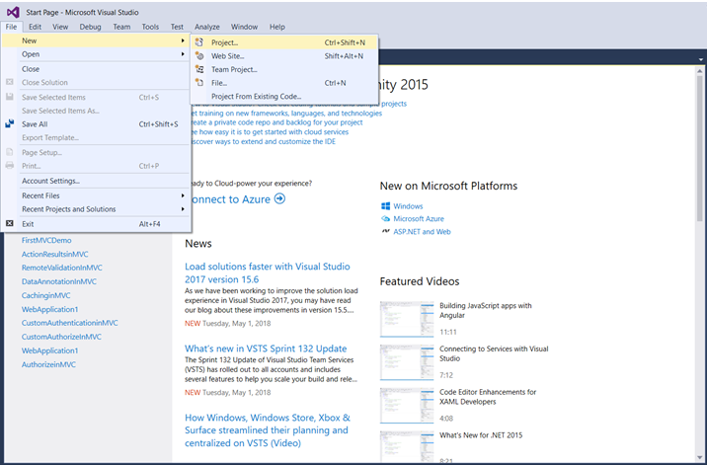

From the “**New Project**” window, from the left pane select the “**Visual C#**” which is under the “**Installed – Templates**” section. Similarly, from the middle pane select **ASP.NET Web Application**and then provide the name of the project as “**EmployeeService**“. Finally, click on the “**OK**” button as shown in the image below.

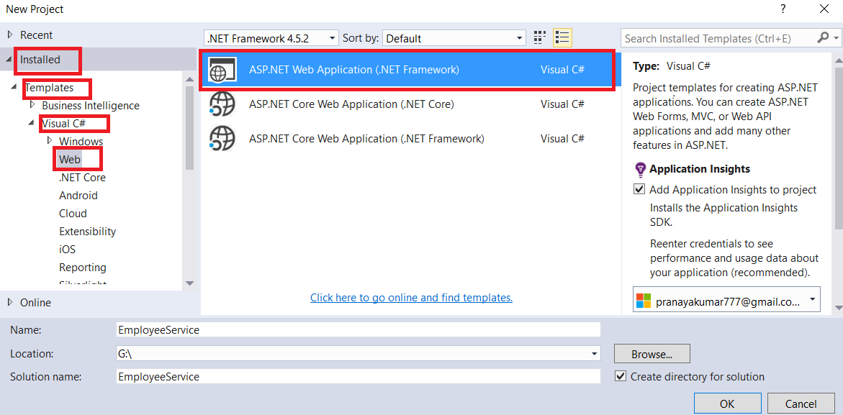

Once we click on the **OK** button a new dialog will pop up with Name “**New ASP.NET Project**” for selecting project Templates.



In this dialog, we are going to choose the Web API project template and click on the **OK** button. At this point, you should have the Web API project created.

**Adding ADO.NET Entity Data Model to retrieve data from the database**

Right-click on the Models folder and then select **Add – New Item**option which will open the Add New Item window and from the “**Add New Item**” window select the “**Data**” option from the left pane and from the middle pane select **ADO.NET Entity Data Model.**In the Name text box, type **EmployeeDataModel** and finally click the **Add**button as shown in the below image.



Once you click on the **Add** button, it will open the **Entity Data Model Wizard** and from that wizard select “**EF Designer from database**” option and click on the “**Next”** button as shown below.



On the next screen, click on the “**New Connection**” button as shown in the image below

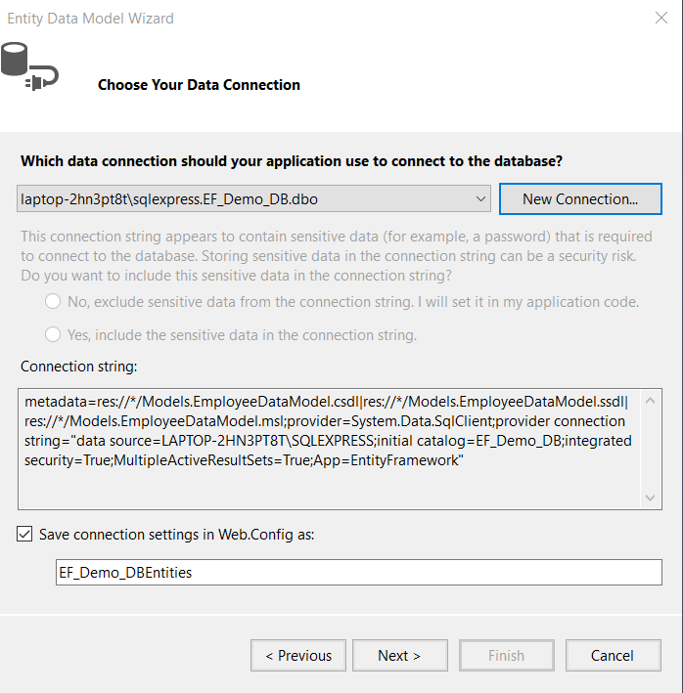

Once you click on the **New Connection** Button it will open the **Connection Properties** window. On “**Connection Properties**” window, set

1. **Server Name =** provide the server name
2. **Authentication =** Select the authentication type
3. **Select or enter a database name =** WEBAPI\_DB
4. Click the **OK** button as shown below.



Once you click on the **OK** button it will navigate back to the Choose Your Data Connection wizard. Here Modify the Connection String as **EmployeeDBContext** and click on the Next Button as shown in the below image.



On the next screen, select Entity Framework 6.x as shown in the below image. This step may be optional if you are using a higher version of visual studio.



On Choose Your Database Objects and Settings screen, select the “Employees” table, provide the model namespace name and click on Finish button as shown below.



Once you click on the Finish Button the following edmx file will be generated within the Models folder as shown below.



**Adding Web API Controller**

Right-click on the Controllers folder and select**Add – Controller**option and then select “**Web API 2 Controller – Empty**” and click on the “**Add**” button as shown below.

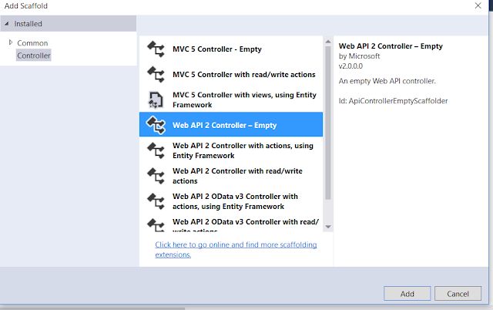

On the next screen set, the Controller Name as **EmployeesController** and click on the **Add** button as shown in the below image.

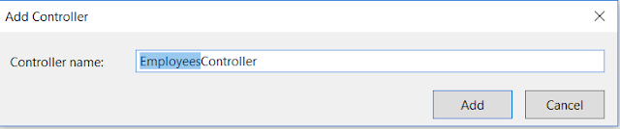

**Implementing the GET method in ASP.NET Web API:**

Copy and paste the following code in EmployeesController.cs

**public** **class** EmployeesController : ApiController

**{**

**public** IEnumerable**<**Employee**>** Get**()**

**{**

**using** **(**EmployeeDBContext dbContext = new EmployeeDBContext**())**

**{**

**return** dbContext.Employees.ToList**()**;

**}**

**}**

**public** Employee Get**(int** id**)**

**{**

**using** **(**EmployeeDBContext dbContext = new EmployeeDBContext**())**

**{**

**return** dbContext.Employees.FirstOrDefault**(**e =**>** e.ID == id**)**;

**}**

**}**

**}**

At this point when we navigate to **/api/employees** we should see all employees and when we navigate to **/api/employees/1** we should see all the details of the employee whose Id=1

We have two get methods one without parameter and one with a parameter. Whenever we pass the id parameter then it will return the employee whose id we passed and if we do not pass the id parameter value then it will return all the employees.

**Let’s see what will happen when we issue a request for an employee whose id that does not exist with one example.**

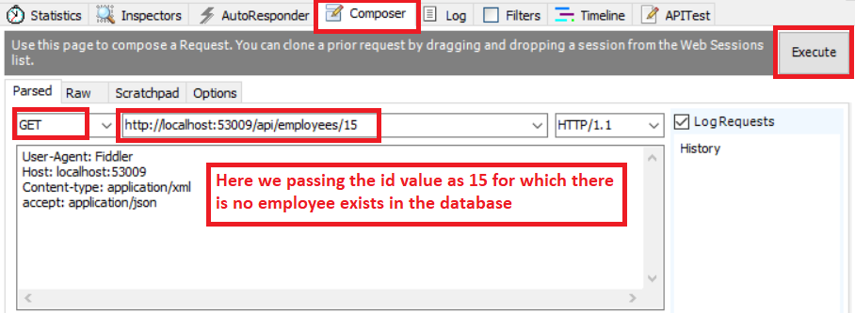

Here we are trying to get the details of an employee whose id does not exist in the database. So when we click on the execute button it will give us the below response.

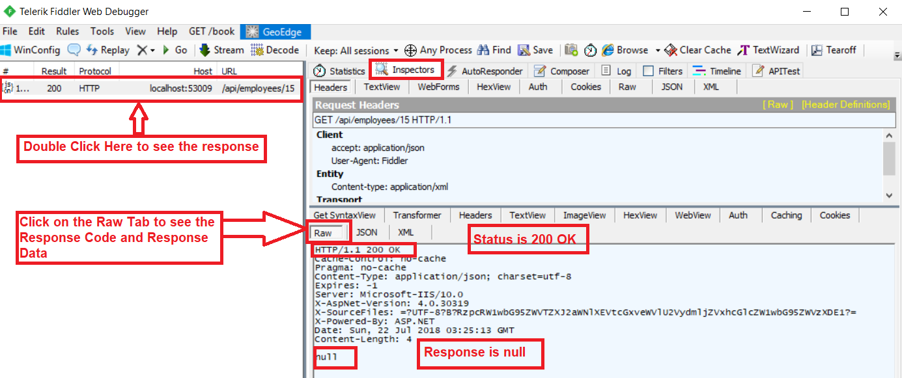

The above image clearly shows that we get null as the response and the status code is 200 OK. According to the standards of REST when an item is not found, then it should return 404 Not Found.

**To achieve this, we need to modify the Employees Controller as shown below.**

**public** **class** EmployeesController : ApiController

**{**

**public** HttpResponseMessage Get**()**

**{**

**using** **(**EmployeeDBContext dbContext = new EmployeeDBContext**())**

**{**

var Employees = dbContext.Employees.ToList**()**;

**return** Request.CreateResponse**(**HttpStatusCode.OK, Employees**)**;

**}**

**}**

**public** HttpResponseMessage Get**(int** id**)**

**{**

**using** **(**EmployeeDBContext dbContext = new EmployeeDBContext**())**

**{**

var entity = dbContext.Employees.FirstOrDefault**(**e =**>** e.ID == id**)**;

**if(**entity != **null)**

**{**

**return** Request.CreateResponse**(**HttpStatusCode.OK, entity**)**;

**}**

**else**

**{**

**return** Request.CreateErrorResponse**(**HttpStatusCode.NotFound,

"Employee with ID " + id.ToString**()** + "not found"**)**;

**}**

**}**

**}**

**}**

At this point, when we issue a request for an employee with ID = 15 which does not exist we get a 404 along with the message “**Employee with Id 15 not found**” as shown below.

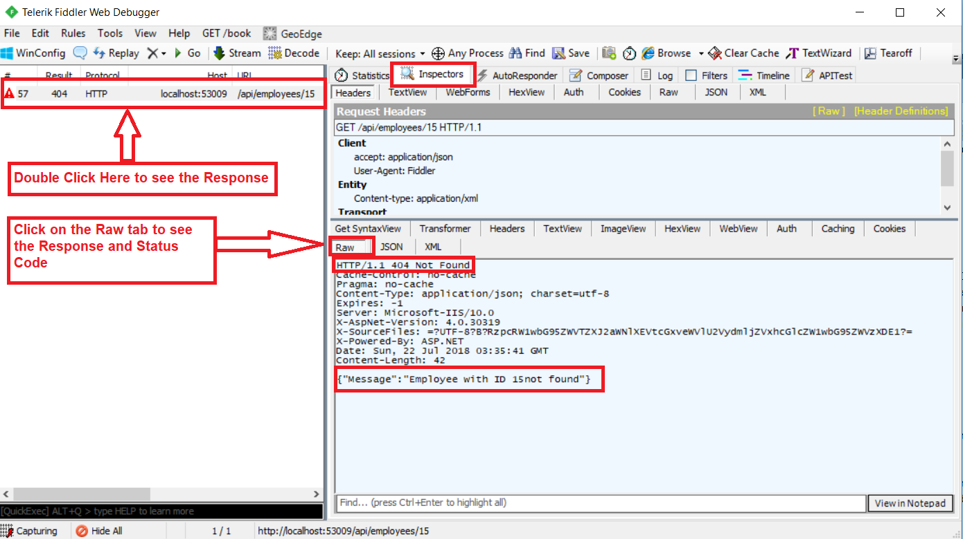

**How to Implement POST Method in Web API**

1. **How to Implement the POST method in Web API Application?**
2. **Understanding the FromBody Attribute in Web API.**
3. **Testing the Web API Post method using Fiddler.**
4. **Understanding the HttpResponseMessage return type in Web API.**

**How to Implement the POST Method in Web API Application?**

The **Post Method in Web API** application allows us to create a new item. Here, we want to add a new Employee to the Employees table. First, Include the following Post() method within the **EmployeesController**. Notice that the Employee object is being passed as a parameter to the Post method.

The Employee parameter is decorated with the **[FromBody]** attribute. We will discuss**[FromBody]** attribute in details in a later article but for now to understand this **[FormBody]** attribute tells the Web API to get the employee data from the request body.

**public** **class** EmployeesController : ApiController

**{**

**public** **void** Post**([**FromBody**]** Employee employee**)**

**{**

**using** **(**EmployeeDBContext dbContext = new EmployeeDBContext**())**

**{**

dbContext.Employees.Add**(**employee**)**;

dbContext.SaveChanges**()**;

**}**

**}**

**}**

At this point build the solution. Run the application and Fire up Fiddler and issue a Post request

1. Set the HTTP verb to POST
2. Content-Type: application/json. This tells that we are sending JSON formatted data to the server
3. In the Request Body, include the employee object that we want to add to the Employees database table in JSON format
4. Finally, click on the Execute button as shown in the below image

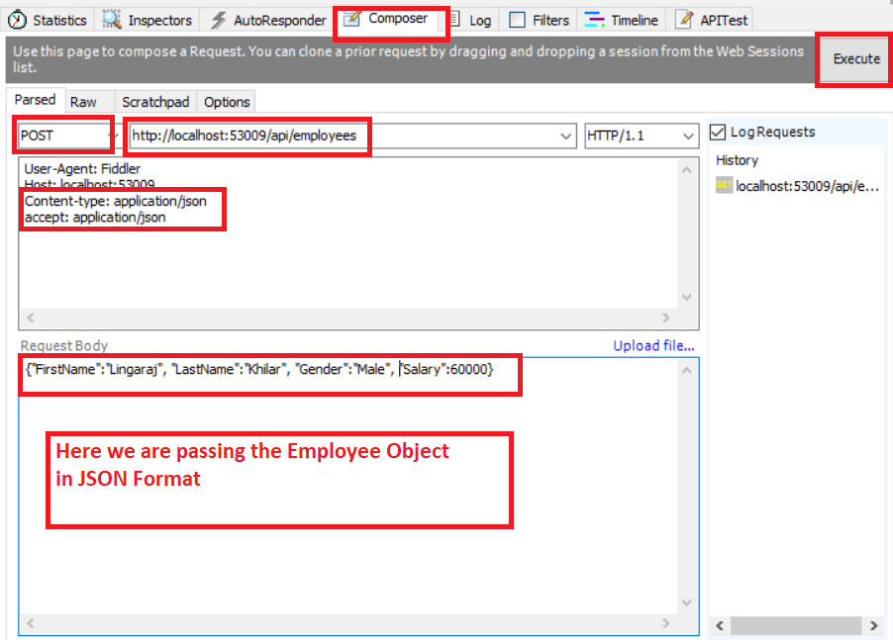   When we click on the Execute button, it will give us the below Response.

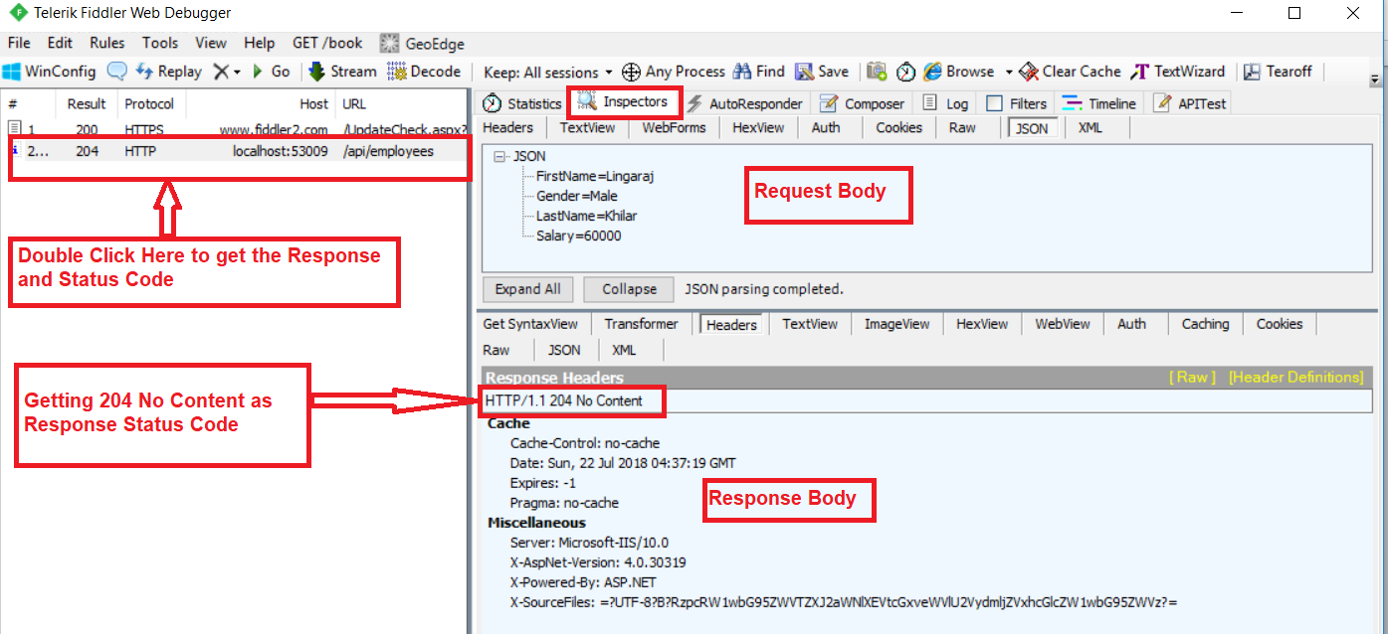

This works fine and adds the employee to the database as expected. The problem here is that since the return type of the Post method is void, we get status code 204 No Content. As per REST standard, when a new item is created, it should return the status code 201 Item Created. With 201 status code, we may also include the location i.e. URI of the newly created item.

**Let’s see how to achieve this. To achieve this, we need to modify the POST method as shown below.**

**public** **class** EmployeesController : ApiController

**{**

**public** HttpResponseMessage Post**([**FromBody**]** Employee employee**)**

**{**

**try**

**{**

**using** **(**EmployeeDBContext dbContext = new EmployeeDBContext**())**

**{**

dbContext.Employees.Add**(**employee**)**;

dbContext.SaveChanges**()**;

var message = Request.CreateResponse**(**HttpStatusCode.Created, employee**)**;

message.Headers.Location = new Uri**(**Request.RequestUri +

employee.ID.ToString**())**;

**return** message;

**}**

**}**

**catch** **(**Exception ex**)**

**{**

**return** Request.CreateErrorResponse**(**HttpStatusCode.BadRequest, ex**)**;

**}**

**}**

**}**

At this point, issue another Post request from Fiddler. Notice in the response header we have status code 201 Created and also the location i.e. the URI of the newly created item as shown in the below image.

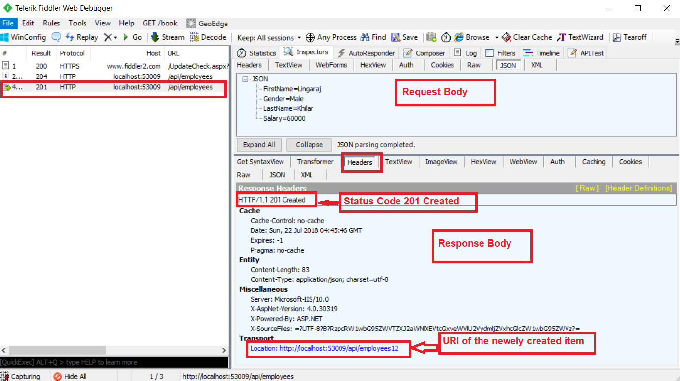

**Points to Remember while working with Web API Post Method:**

1. If a method return type is void in Web API Service then by default Web API Service return the status code 204 No Content.
2. When a new item is created, we should be returning status code 201 Item Created.
3. With 201 status code, we should also include the location i.e. URI of the newly created item.
4. When an item is not found, instead of returning NULL and status code 200 OK, return 404 Not Found status code along with a meaningful message such as “**Employee with Id = 15 not found**“

**How to Implement PUT Method in Web API**

1. **How to Implement the PUT method in Web API?**
2. **Testing the PUT method using Fiddler.**

**How to Implement PUT method in ASP.NET Web API?**

The PUT method in Web API allows us to update an item. Here, we want to update the employee by Id. Include the following Put method in EmployeesController. Notice the id of the employee that we want to update and the Employee object with which we want to update are being passed as parameters to the Post method. The Employee parameter is decorated with the [**FromBody**] attribute. This tells Web API to get employee data from the request body.

**public** **class** EmployeesController : ApiController

**{**

**public** **void** Put**(int** id, **[**FromBody**]**Employee employee**)**

**{**

**using** **(**EmployeeDBContext dbContext = new EmployeeDBContext**())**

**{**

var entity = dbContext.Employees.FirstOrDefault**(**e =**>** e.ID == id**)**;

entity.FirstName = employee.FirstName;

entity.LastName = employee.LastName;

entity.Gender = employee.Gender;

entity.Salary = employee.Salary;

dbContext.SaveChanges**()**;

**}**

**}**

**}**

**At this point build the solution, run the application and fire up Fiddler and issue a Put request.**

1. Set the HTTP verb to PUT
2. Content-Type: application/json. This tells that we are sending JSON formatted data to the server
3. In the Request Body, include the updated employee object with which you want to update
4. Finally, click on the execute button as shown below

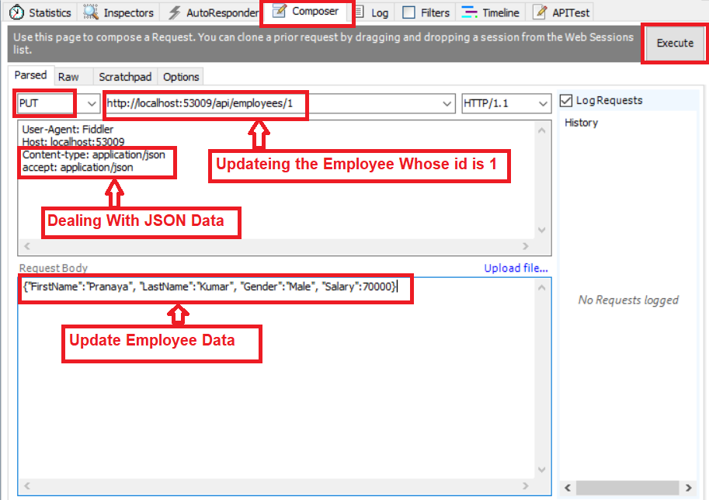

**When we click on the Execute button, it will give us the below response.**

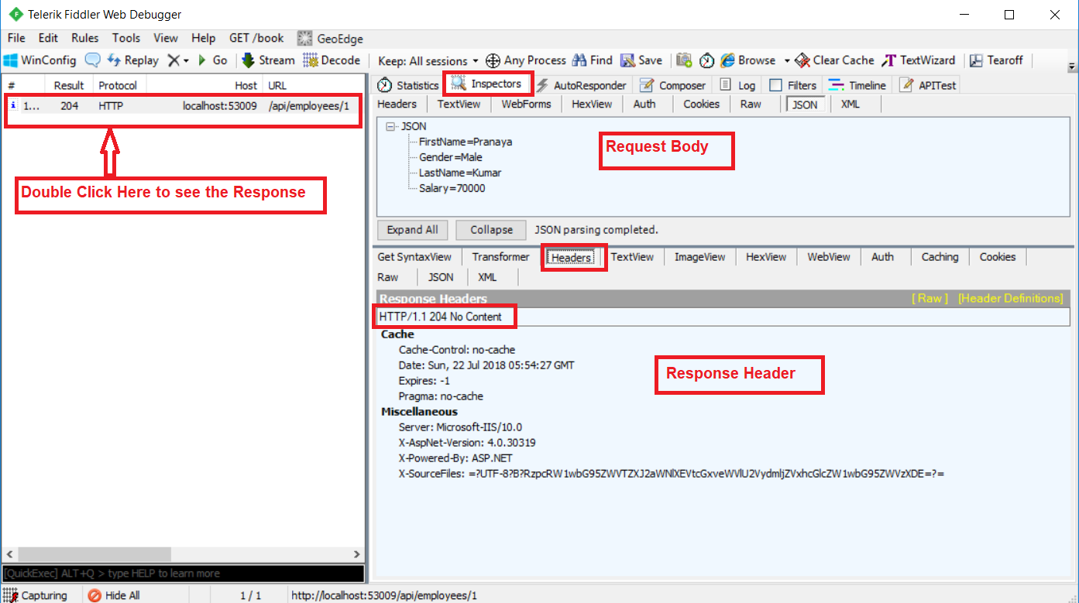

This works fine and updates the employee record in the database as expected. The problem here is that since the return type of the Put method is void, we get status code 204 No Content. When the update is successful, we want to return status code 200 OK indicating that the update is successful.

Also when we try to update an employee whose Id does not exist we get back HTTP status code 500 Internal Server Error. We get status code 500, because of a NULL reference exception. To fix both of these issues modify the code in the Put method as shown below.

**public** **class** EmployeesController : ApiController

**{**

**public** HttpResponseMessage Put**(int** id, **[**FromBody**]**Employee employee**)**

**{**

**try**

**{**

**using** **(**EmployeeDBContext dbContext = new EmployeeDBContext**())**

**{**

var entity = dbContext.Employees.FirstOrDefault**(**e =**>** e.ID == id**)**;

**if** **(**entity == **null)**

**{**

**return** Request.CreateErrorResponse**(**HttpStatusCode.NotFound,

"Employee with Id " + id.ToString**()** + " not found to update"**)**;

**}**

**else**

**{**

entity.FirstName = employee.FirstName;

entity.LastName = employee.LastName;

entity.Gender = employee.Gender;

entity.Salary = employee.Salary;

dbContext.SaveChanges**()**;

**return** Request.CreateResponse**(**HttpStatusCode.OK, entity**)**;

**}**

**}**

**}**

**catch** **(**Exception ex**)**

**{**

**return** Request.CreateErrorResponse**(**HttpStatusCode.BadRequest, ex**)**;

**}**

**}**

**}**

At this point, issue another Put request from Fiddler. Notice in the response header we have status code 200 OK. Also, when we try to update an employee whose id does not exist, we get status code 404 Not Found instead of 500 Internal Server Error

**How to Implement DELETE Method in Web API**

1. **How to Implement the Delete Method in Web API Application?**
2. **Testing Delete Method in Web API.**

**How to Implement the DELETE Method in ASP.NET Web API?**

The Delete Method in Web API allows us to delete an item. We want to delete a specified employee from the Employees database table. To achieve this Include the following Delete method in EmployeesController.

**public** **class** EmployeesController : ApiController

**{**

**public** **void** Delete**(int** id**)**

**{**

**using** **(**EmployeeDBContext dbContext = new EmployeeDBContext**())**

**{**

dbContext.Employees.Remove**(**dbContext.Employees.FirstOrDefault**(**e =**>** e.ID == id**))**;

dbContext.SaveChanges**()**;

**}**

**}**

**}**

At this point build the solution, run the application and fire up the Fiddler and issue a Delete request.

1. Set the HTTP verb to DELETE
2. Content-Type: application/json. This tells that we are sending JSON formatted data to the server
3. Finally, click on the execute button as shown below

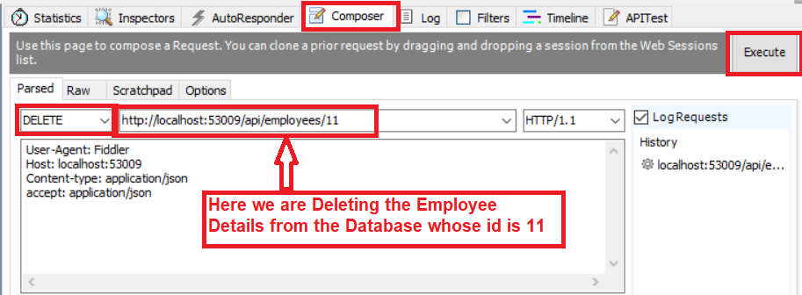

**When we click on the Execute button, it will give us the below response**

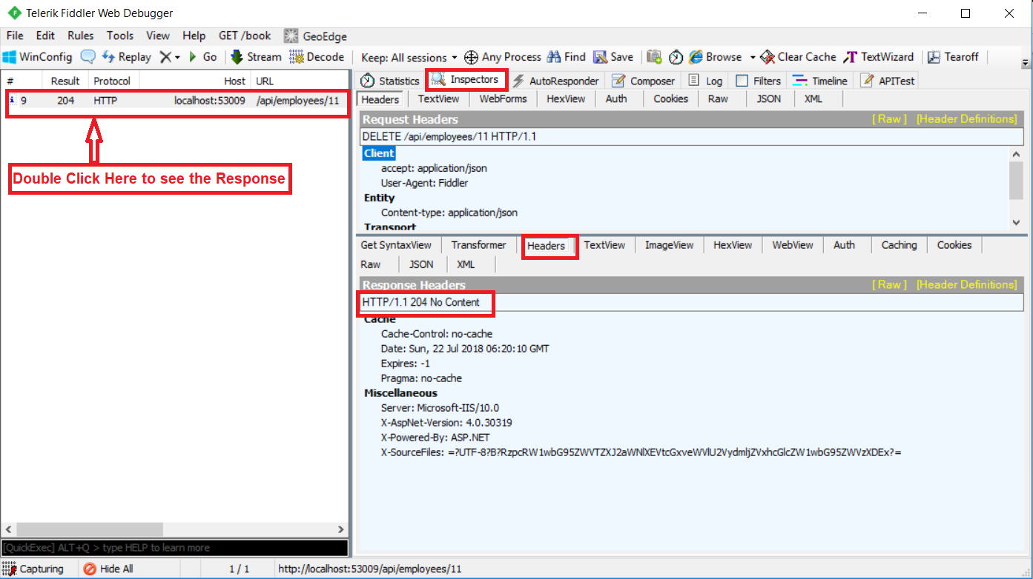

This works fine and deletes the employee record from the database as expected. The problem here is that since the return type of the Delete method is void, we get status code **204 No Content**. When the Deletion is successful, we want to return status code **200 OK** indicating that the deletion is successful.

Also when we try to delete an employee whose Id does not exist we get back HTTP status code **500 Internal Server Error**. We get status code 500, because of a **NULL reference exception**. If an item is not found, then we need to return status code **404 Not Found**.

**How to Fix the above issues?**

To fix both of these issues modify the code in the Delete method as shown below.

**public** **class** EmployeesController : ApiController

**{**

**public** HttpResponseMessage Delete**(int** id**)**

**{**

**try**

**{**

**using** **(**EmployeeDBContext dbContext = new EmployeeDBContext**())**

**{**

var entity = dbContext.Employees.FirstOrDefault**(**e =**>** e.ID == id**)**;

**if** **(**entity == **null)**

**{**

**return** Request.CreateErrorResponse**(**HttpStatusCode.NotFound,

"Employee with Id = " + id.ToString**()** + " not found to delete"**)**;

**}**

**else**

**{**

dbContext.Employees.Remove**(**entity**)**;

dbContext.SaveChanges**()**;

**return** Request.CreateResponse**(**HttpStatusCode.OK**)**;

**}**

**}**

**}**

**catch** **(**Exception ex**)**

**{**

**return** Request.CreateErrorResponse**(**HttpStatusCode.BadRequest, ex**)**;

**}**

**}**

**}**

At this point, issue another DELETE request from the Fiddler. Notice in the response header we have status code **200 OK**. Also, when we try to delete an employee whose id does not exist, we get status code **404 Not Found** instead of **500 Internal Server Error**

**Custom Method Names in Web API**

1. **Understanding the Default Convention used by ASP.NET Web API.**
2. **Why do we need to create custom action method names in Web API?**
3. **How to create Custom Method Names in ASP.NET Web API??**

**Understanding the Default Convention used by ASP.NET Web API.**

Let’s understand the default convention used by ASP.NET Web API to map HTTP verbs GET, PUT, POST and DELETE to methods in a controller with an example.

By default, the HTTP verb GET is mapped to a method in a controller that has the name Get() or starts with the word Get.

In the following **EmployeesController**, the method name is **Get()** so by default convention, this is mapped to the HTTP verb GET. Even if we rename it to **GetEmployees()** or **GetSomething()** it will still be mapped to the HTTP verb GET as long as the name of the method is prefixed with the word Get. The word Get is case-insensitive. It can be lowercase, uppercase or a mix of both.

**public** **class** EmployeesController : ApiController

**{**

**public** HttpResponseMessage Get**()**

**{**

**using** **(**EmployeeDBContext dbContext = new EmployeeDBContext**())**

**{**

var Employees = dbContext.Employees.ToList**()**;

**return** Request.CreateResponse**(**HttpStatusCode.OK, Employees**)**;

**}**

**}**

**}**

If the method is not named as GET or if it does not start with the word GET then Web API does not know the method name to which, the GET request must be mapped and the request fails with an error message stating **The requested resource does not support HTTP method ‘GET’ with the status code 405 Method Not Allowed.**

In the following example, we have renamed Get() method to LoadAllEmployees(). When we issue a GET request the request will fail because ASP.NET Web API does not know it has to map the GET request to this method.

**public** **class** EmployeesController : ApiController

**{**

**public** HttpResponseMessage LoadAllEmployees**()**

**{**

**using** **(**EmployeeDBContext dbContext = new EmployeeDBContext**())**

**{**

var Employees = dbContext.Employees.ToList**()**;

**return** Request.CreateResponse**(**HttpStatusCode.OK, Employees**)**;

**}**

**}**

**}**

To instruct Web API to map HTTP verb GET to LoadAllEmployees() method, decorate the method with [HttpGet] attribute as shown below.

**public** **class** EmployeesController : ApiController

**{**

**[**HttpGet**]**

**public** HttpResponseMessage LoadAllEmployees**()**

**{**

**using** **(**EmployeeDBContext dbContext = new EmployeeDBContext**())**

**{**

var Employees = dbContext.Employees.ToList**()**;

**return** Request.CreateResponse**(**HttpStatusCode.OK, Employees**)**;

**}**

**}**

**}**

**Let’s say we have the following two methods in our Employee API controller.**

**public** **class** EmployeesController : ApiController

**{**

**[**HttpGet**]**

**public** HttpResponseMessage LoadAllEmployees**()**

**{**

**using** **(**EmployeeDBContext dbContext = new EmployeeDBContext**())**

**{**

var Employees = dbContext.Employees.ToList**()**;

**return** Request.CreateResponse**(**HttpStatusCode.OK, Employees**)**;

**}**

**}**

**public** HttpResponseMessage LoadEmployeeByID**(int** id**)**

**{**

**using** **(**EmployeeDBContext dbContext = new EmployeeDBContext**())**

**{**

var entity = dbContext.Employees.FirstOrDefault**(**e =**>** e.ID == id**)**;

**if** **(**entity != **null)**

**{**

**return** Request.CreateResponse**(**HttpStatusCode.OK, entity**)**;

**}**

**else**

**{**

**return** Request.CreateErrorResponse**(**HttpStatusCode.NotFound,

"Employee with ID " + id.ToString**()** + "not found"**)**;

**}**

**}**

**}**

**}**

When we navigate to the URI **/api/employees/1**

Notice, we are getting all the Employees, instead of just the Employee with Id=1. This is because in this case the GET request is mapped to **LoadAllEmployees**() and not to **LoadEmployeeById(int id).**

If you want the GET request to be mapped to LoadEmployeeById(int id) when the id parameter is specified in the URI, then decorate the LoadEmployeeById(int id) method also with [HttpGet] attribute as shown below.

**public** **class** EmployeesController : ApiController

**{**

**[**HttpGet**]**

**public** HttpResponseMessage LoadAllEmployees**()**

**{**

**using** **(**EmployeeDBContext dbContext = new EmployeeDBContext**())**

**{**

var Employees = dbContext.Employees.ToList**()**;

**return** Request.CreateResponse**(**HttpStatusCode.OK, Employees**)**;

**}**

**}**

**[**HttpGet**]**

**public** HttpResponseMessage LoadEmployeeByID**(int** id**)**

**{**

**using** **(**EmployeeDBContext dbContext = new EmployeeDBContext**())**

**{**

var entity = dbContext.Employees.FirstOrDefault**(**e =**>** e.ID == id**)**;

**if** **(**entity != **null)**

**{**

**return** Request.CreateResponse**(**HttpStatusCode.OK, entity**)**;

**}**

**else**

**{**

**return** Request.CreateErrorResponse**(**HttpStatusCode.NotFound,

"Employee with ID " + id.ToString**()** + "not found"**)**;

**}**

**}**

**}**

**}**

That’s OK. But in real-time we may have to implement multiple get or post or put method within a single controller. For example, we have two methods as shown below

**public** **class** EmployeesController : ApiController

**{**

**[**HttpGet**]**

**public** HttpResponseMessage LoadAllEmployees**()**

**{**

**using** **(**EmployeeDBContext dbContext = new EmployeeDBContext**())**

**{**

var Employees = dbContext.Employees.ToList**()**;

**return** Request.CreateResponse**(**HttpStatusCode.OK, Employees**)**;

**}**

**}**

**[**HttpGet**]**

**public** HttpResponseMessage LoadAllMaleEmployees**()**

**{**

**using** **(**EmployeeDBContext dbContext = new EmployeeDBContext**())**

**{**

var Employees = dbContext.Employees.Where**(**x =**>** x.Gender == "Male"**)**.ToList**()**;

**return** Request.CreateResponse**(**HttpStatusCode.OK, Employees**)**;

**}**

**}**

**}**

**Now when we make a request with the URL /api/employees**We will get the below error

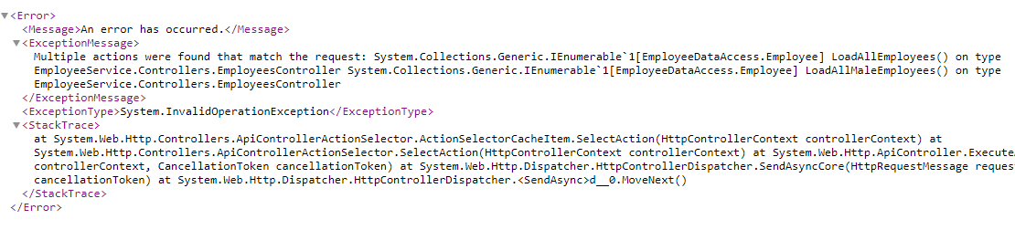

Now the question is how to access these two methods along with how we will provide a unique URL to each resource.

**First, let’s see the default implementation of the WebApiConfig class which is present in App\_Start Folder.**

**public** **static** **class** WebApiConfig

**{**

**public** **static** **void** Register**(**HttpConfiguration config**)**

**{**

// Web API routes

config.MapHttpAttributeRoutes**()**;

config.Routes.MapHttpRoute**(**

name: "DefaultApi",

routeTemplate: "api/{controller}/{id}",

defaults: new **{** id = RouteParameter.Optional **}**

**)**;

**}**

**}**

The default route specifies the URL route as domain Name Followed by API and controller name. In our example, it will be **http://localhost:xxxxx/api/employees** where “employees” is the controller name.

**Implementing Custom Method Names in Web API:**

To implement Custom Method Names in Web API, Let’s change first the default implementation of the WebApiConfig class as shown below where we include the action name as part of the route.

**public** **static** **class** WebApiConfig

**{**

**public** **static** **void** Register**(**HttpConfiguration config**)**

**{**

// Web API routes

config.MapHttpAttributeRoutes**()**;

config.Routes.MapHttpRoute**(**

name: "DefaultApi",

routeTemplate: "api/{controller}/{action}/{id}",

defaults: new **{** id = RouteParameter.Optional **}**

**)**;

**}**

**}**

**Now make a request with the same URL /api/employees**It will give us the following error

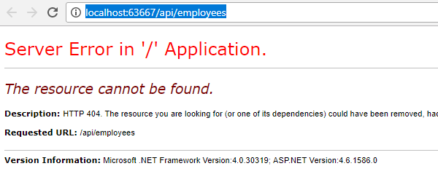

So change the URL as we need to include the action name in the URL as we do the changes in the WebApiConfig class.

**/api/employees/LoadAllEmployees**  
**/api/employees/LoadAllMaleEmployees**

That’s it. We have successfully implemented Custom Method Names in Web API. Now you will get the response as expected.

**Parameter Binding in Web API**

1. **What do you mean by Parameter Binding in Web API?**
2. **Understanding the Default Parameter Binding in ASP.NET Web API.**
3. **Understanding the Parameter Binding in ASP.NET Web API with an Example.**
4. **Understanding FromBody and FromUri attributes**
5. **How to change the Default Parameter Binding Convention used by ASP.NET Web API Framework.**

**What do you mean by Parameter Binding in Web API?**

The Parameter Binding in ASP.NET Web API means how the Web API Framework binds the incoming HTTP request data to the parameters of an action method of a Web API controller.

The ASP.NET Web API action methods can take one or more parameters of different types. An action method parameters can be either of a complex type or primitive types. The Web API Framework binds the action method parameters either with the URL’s query string or from the request body of the incoming HTTP Request based on the parameter type.

**Default Parameter Binding in Web API**

By default, if the parameter type is of the primitive type such as int, bool, double, string, GUID, DateTime, decimal or any other type that can be converted from the string type then Web API Framework sets the action method parameter value from the query string. And if the action method parameter type is a complex type then Web API Framework tries to get the value from the body of the request and this is the default nature of Parameter Binding in Web API Framework.

**The following table lists the default rules for Web API Parameter Binding.**

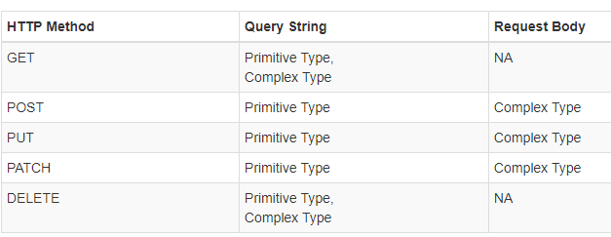

**Note:** From the above diagram it clearly shows that we do not have a request body for GET and DELETE HTTP request. So, in that case, it tries to get the data from the query string.

**Understanding the Parameter Binding in ASP.NET Web API with an Example.**

We are going to use a testing tool called “Fiddler” to test these Verbs. Again we are going to use the following Employee table to understand the Parameter binding in Web API concepts.



Please use the following SQL Script which will create and populate the Employees database table along with the database with the required test data.

**CREATE** **DATABASE** WEBAPI\_DB

**GO**

**USE** WEBAPI\_DB

**GO**

**CREATE** **TABLE** Employees

(

**ID** int primary key identity,

FirstName nvarchar(50),

LastName nvarchar(50),

Gender nvarchar(50),

Salary int

)

**GO**

**INSERT** **INTO** Employees **VALUES** ('Pranaya', 'Rout', 'Male', 60000)

**INSERT** **INTO** Employees **VALUES** ('Anurag', 'Mohanty', 'Male', 45000)

**INSERT** **INTO** Employees **VALUES** ('Preety', 'Tiwari', 'Female', 45000)

**INSERT** **INTO** Employees **VALUES** ('Sambit', 'Mohanty', 'Male', 70000)

**INSERT** **INTO** Employees **VALUES** ('Shushanta', 'Jena', 'Male', 45000)

**INSERT** **INTO** Employees **VALUES** ('Priyanka', 'Dewangan', 'Female', 30000)

**INSERT** **INTO** Employees **VALUES** ('Sandeep', 'Kiran', 'Male', 45000)

**INSERT** **INTO** Employees **VALUES**('Shudhansshu', 'Nayak', 'Male', 30000)

**INSERT** **INTO** Employees **VALUES** ('Hina', 'Sharma', 'Female', 35000)

**INSERT** **INTO** Employees **VALUES** ('Preetiranjan', 'Sahoo', 'Male', 80000)

**GO**

**Creating a new ASP.NET Web API Project**

Open Visual Studio and select **File -> New –> Project** as shown below



In the “**New Project**” window, select “**Visual C#**” under the “**Installed – Templates**” section. From the middle pane select the “**ASP.NET Web Application**” and then give a meaningful name to your application, here I provided the name as “**EmployeeService**” and then click on the “**OK**” button as shown in the below image



Once you click on the **OK** button a new dialog window will open with Name “**New ASP.NET Projec**t” for selecting the Project Templates. From this window, you need to choose the **WEB API** project template and then click on the **OK** button as shown below.



At this point, you should have the Web API project created.

**Adding ADO.NET Entity Data Model to retrieve data from the database**

Right-click on the **Models** folder and then select **Add -> New Item**option which will open the Add New Item windows. From the “**Add New Item**” window select the “**Data**” from the left pane and then select the **ADO.NET Entity Data Model** from the middle pane of the Add New Item window.

In the name text box, provide a meaningful nake like **EmployeeDataModel** and click on the **Add**button as shown in the below image.



On the Entity Data Model Wizard, select “**EF Designer from database**” option and click the **Next** button



From the Choose Your Data Connection screen, click on the “**New Connection**” button as shown below



Once you click on the **New Connection** Button it will open the Connection Properties window and from the “**Connection Properties**” window, set the following things

1. Server Name = provide the server
2. Authentication = Select the authentication type
3. Select or enter a database name = WEBAPI\_DB
4. Click the OK button as shown below.



Once you click on the **OK** button it will navigate back to the Choose Your Data Connection wizard. Here Modify the Connection String as **EmployeeDBContext** and click on the **Next** Button as shown in the below image.



On the next screen, select **Entity Framework 6.x** as shown in the below image. This step may be optional if you are using a higher version of visual studio.



On Choose Your Database Objects and Settings screen, select the “**Employees**” table, provide the model namespace name and click on the Finish button as shown below.



Once you click on the Finish Button the edmx file will be generated.

**Adding Web API Controller**

Right-click on the **Controllers** folder and select **Add -> Controller**which will open a window to select the controller. From that window select “**Web API 2 Controller – Empty**” and then click on the “**Add**” button as shown below.



On the next screen set, the Controller Name as EmployeesController and click on the Add button as shown in the below image.



**Copy and paste the following code in** **EmployeesController.**

**public** **class** EmployeesController : ApiController

**{**

**public** HttpResponseMessage GET**()**

**{**

**using** **(**EmployeeDBContext dbContext = new EmployeeDBContext**())**

**{**

var Employees = dbContext.Employees.ToList**()**;

**return** Request.CreateResponse**(**HttpStatusCode.OK, Employees**)**;

**}**

**}**

**}**

Depending on the value we specify for query string parameter gender, the Get() method should return the data.

**/api/employees?gender=all** Return All Employees

**/api/employees?gender=Male** Return All Male Employees

**/api/employees?gender=Female** Return All Female Employees

If the value for gender is not Male, Female or All, then the service should return status code **400 Bad Request.** For example, if we specify **ABC**as the value for gender, then the service should return status code **400 Bad Request** with the following message.

**Value for gender must be Male, Female or All. ABC is invalid.**

**Below is the modified Get() method**

Gender is being passed as a parameter to the Get() method. The default value is “All”. The default value makes the parameter optional. The gender parameter of the Get() method is mapped to the gender parameter sent in the query string

**public** **class** EmployeesController : ApiController

**{**

**public** HttpResponseMessage Get**(**string gender = "All"**)**

**{**

**using** **(**EmployeeDBContext dbContext = new EmployeeDBContext**())**

**{**

**switch** **(**gender.ToLower**())**

**{**

**case** "all":

**return** Request.CreateResponse**(**HttpStatusCode.OK,

dbContext.Employees.ToList**())**;

**case** "male":

**return** Request.CreateResponse**(**HttpStatusCode.OK,

dbContext.Employees.Where**(**e =**>** e.Gender.ToLower**()** == "male"**)**.ToList**())**;

**case** "female":

**return** Request.CreateResponse**(**HttpStatusCode.OK,

dbContext.Employees.Where**(**e =**>** e.Gender.ToLower**()** == "female"**)**.ToList**())**;

**default**:

**return** Request.CreateErrorResponse**(**HttpStatusCode.BadRequest,

"Value for gender must be Male, Female or All. " + gender + " is invalid."**)**;

**}**

**}**

**}**

**}**

**Understanding FromBody and FromUri attributes.**

Let us understand their use with an example. Consider the following **Put**() method. This method updates the specified Employee details. Add the following PUT method within the Employees Controller

**public** HttpResponseMessage Put**(int** id, Employee employee**)**

**{**

**try**

**{**

**using** **(**EmployeeDBContext dbContext = new EmployeeDBContext**())**

**{**

var entity = dbContext.Employees.FirstOrDefault**(**e =**>** e.ID == id**)**;

**if** **(**entity == **null)**

**{**

**return** Request.CreateErrorResponse**(**HttpStatusCode.NotFound,

"Employee with Id " + id.ToString**()** + " not found to update"**)**;

**}**

**else**

**{**

entity.FirstName = employee.FirstName;

entity.LastName = employee.LastName;

entity.Gender = employee.Gender;

entity.Salary = employee.Salary;

dbContext.SaveChanges**()**;

**return** Request.CreateResponse**(**HttpStatusCode.OK, entity**)**;

**}**

**}**

**}**

**catch** **(**Exception ex**)**

**{**

**return** Request.CreateErrorResponse**(**HttpStatusCode.BadRequest, ex**)**;

**}**

**}**

To update employee details whose Id is 1 we issue a Put request to the URI **/api/employees/1**

**Note:** Query string parameter names must match with the name of an action method parameter. However, they can be in a different order.

If you are using Fiddler, the PUT request is as shown below. Notice the Id of the employee is in the URI and the employee data is in the request body.

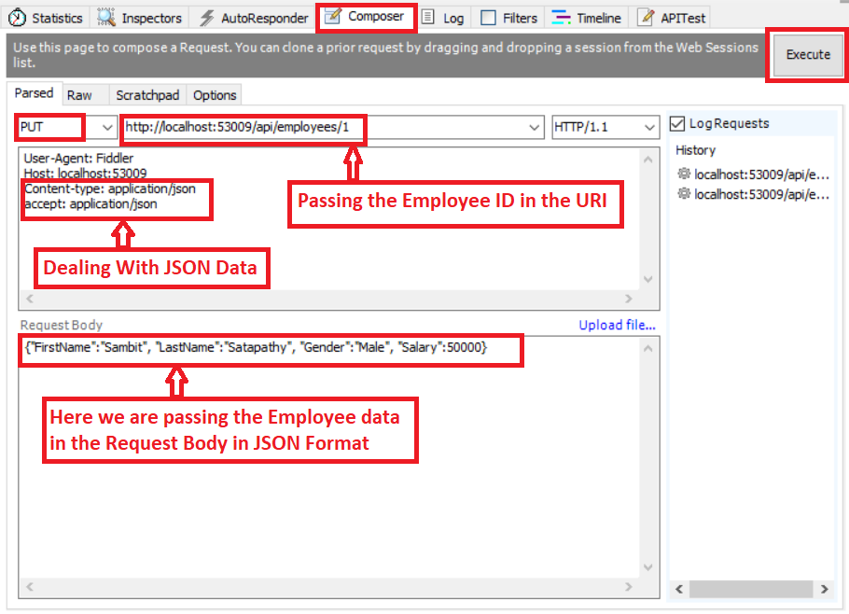

At this point, if you execute the request, the employee data is updated as expected. Now let’s include the Id as a query string parameter. In the first request, Id is specified as part of route data. Notice in Fiddler we have included id parameter as a query string.

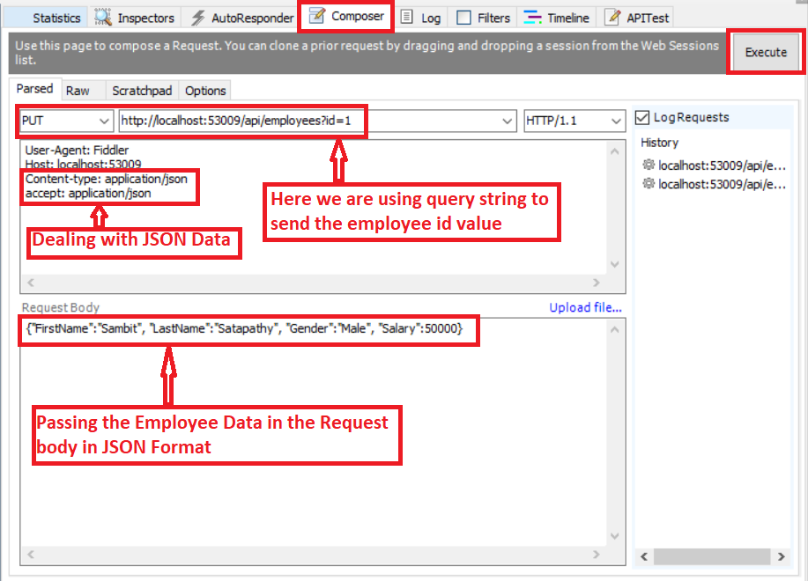

When we execute this request, the update succeeds as expected. When a PUT request is issued, Web API maps the data in the request to the PUT method parameters in the Employees Controller. This process is called Parameter Binding.

**Default convention used by Web API for Parameter binding.**

If the parameter is a simple type like int, bool, double, etc., Web API tries to get the value from the URI (Either from route data or from the Query String) whereas if the parameter is a complex type like Customer, Employee, etc., then the Web API Framework tries to get the value from the request body.

So in our case, the id parameter is a simple type, so Web API tries to get the value from the request URI. The employee parameter is a complex type, so Web API gets the value from the request body.

**Note:** Name of the complex type properties and query string parameters must match.

We can change this default behavior of the **parameter binding** process by using **[FromBody]** and**[FromUri]** attributes. Notice in the example below we have decorated the id parameter with **[FromBody]** attribute which will force the Web API Framework to get it from the request body. We have also decorated the employee object with the **[FromUri]** attribute which will force the Web API Framework to get the employee data from the **URI** (i.e. Route data or Query String)

**public** HttpResponseMessage Put**([**FromBody**]int** id, **[**FromUri**]**Employee employee**)**

**{**

**try**

**{**

**using** **(**EmployeeDBContext dbContext = new EmployeeDBContext**())**

**{**

var entity = dbContext.Employees.FirstOrDefault**(**e =**>** e.ID == id**)**;

**if** **(**entity == **null)**

**{**

**return** Request.CreateErrorResponse**(**HttpStatusCode.NotFound,

"Employee with Id " + id.ToString**()** + " not found to update"**)**;

**}**

**else**

**{**

entity.FirstName = employee.FirstName;

entity.LastName = employee.LastName;

entity.Gender = employee.Gender;

entity.Salary = employee.Salary;

dbContext.SaveChanges**()**;

**return** Request.CreateResponse**(**HttpStatusCode.OK, entity**)**;

**}**

**}**

**}**

**catch** **(**Exception ex**)**

**{**

**return** Request.CreateErrorResponse**(**HttpStatusCode.BadRequest, ex**)**;

**}**

**}**

**Here is the request from Fiddler**

1. Employee data is specified in the URI using query string parameters

2. The id is specified in the request body

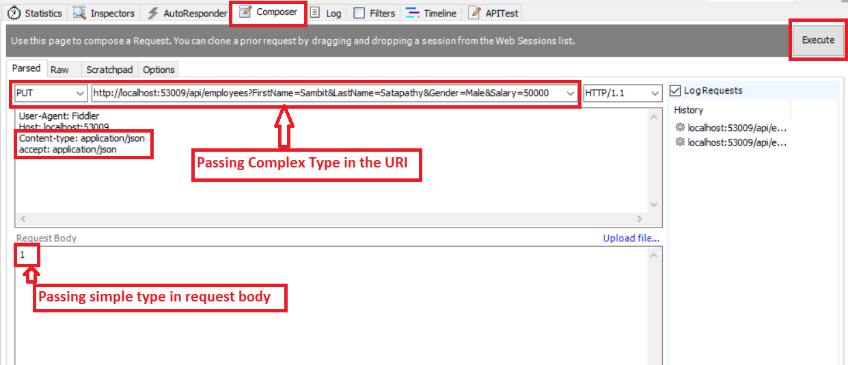 When we execute the request the update succeeds as expected

**Are multiple FormBody attributes is allowed?**

**No**, multiple FormBody is not allowed in a single action.

**Consuming Web API Service From jQuery**

**Business Requirements**:

When we click on the **“Get All Employees”** button, then we need to retrieve all the employee’s information and then display this information in an unordered list as shown in the image below. When we click on the **“Clear”** button then we need to clear the employees from the unordered list.

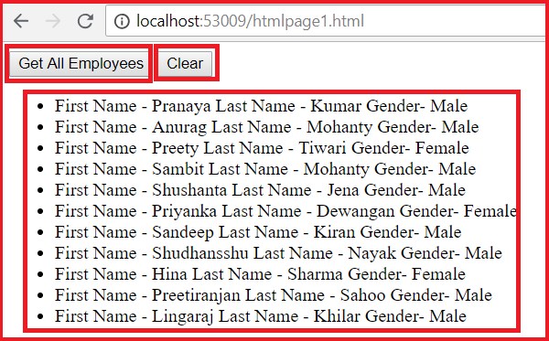

**Let’s discuss how to consuming ASP.NET Web API Service From jQuery**

Modify the Employee Controller of our project as shown below where we create one action which will return the list of employees.

**namespace** *WEB\_API\_Using\_AJAX.Controllers*

**{**

**public** **class** EmployeeController : ApiController

**{**

**[**HttpGet**]**

**public** IEnumerable**<**Employee**>** GetEmployees**()**

**{**

EmployeeDBContext dbContext = new EmployeeDBContext**()**;

**return** dbContext.Employees.ToList**()**;

**}**

**}**

**}**

Then modify the **WebApiConfig** class which is present in the inside **App\_Start** folder as shown below. Here we are changing the URI pattern to allow action name as part of the URL.

**public** **static** **class** WebApiConfig

**{**

**public** **static** **void** Register**(**HttpConfiguration config**)**

**{**

// Web API configuration and services

// Web API routes

config.MapHttpAttributeRoutes**()**;

config.Routes.MapHttpRoute**(**

name: "DefaultApi",

routeTemplate: "api/{controller}/{action}/{id}",

defaults: new **{** id = RouteParameter.Optional **}**

**)**;

**}**

**}**

**Let’s add one Html Page to our project with the name HtmlPage1.html**

Right-click on the project and then select **Add => Html** page as shown below

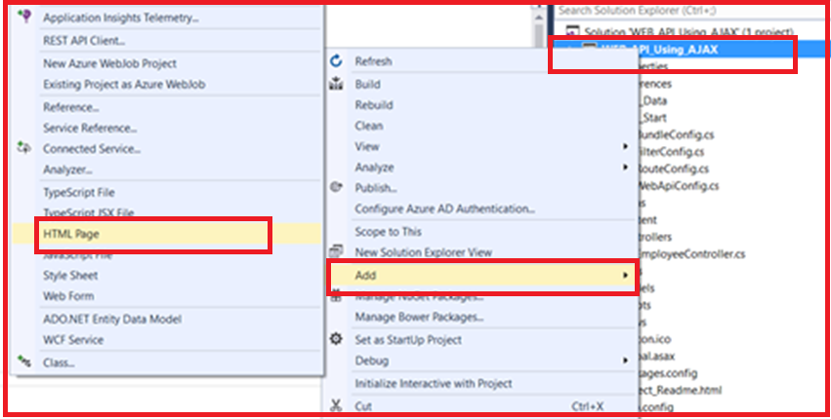

In the next pop up specify the name for the HTML page and then click on the Ok button as shown in the image below

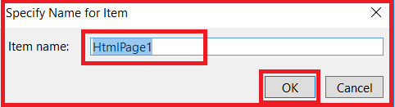

Once you created the page then copy and paste the following code in it.

<!DOCTYPE html>

**<html>**

**<head>**

**<title></title>**

**<meta** charset="utf-8" **/>**

**<script** src="Scripts/jquery-1.10.2.js"**></script>**

**<script** type="text/javascript"**>**

$(document).ready(function () {

var ulEmployees = $('#ulEmployees');

$('#btnGetEmployees').click(function () {

$.ajax({

type: 'GET',

url: "api/Employees/GetEmployees",

dataType: 'json',

success: function (data) {

ulEmployees.empty();

$.each(data, function (index, val) {

ulEmployees.append('**<li>** First Name - ' + val.FirstName + " Last Name - " + val.LastName + " Gender- " + val.Gender + '**</li>**');

});

}

});

});

$('#btnClear').click(function () {

ulEmployees.empty();

});

});

**</script>**

**</head>**

**<body>**

**<div>**

**<input** id="btnGetEmployees" type="button" value="Get All Employees" **/>**

**<input** id="btnClear" type="button" value="Clear" **/>**

**<ul** id="ulEmployees" **/>**

**</div>**

**</body>**

**</html>**

That’s it; now run the application and navigate to the following URL in the browser

**http://localhost:xxxxx/htmlpage1.html**(instead of xxxxx you need to provide the port number where your application is running). It will display the following page.

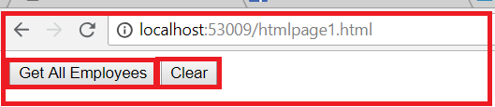

Once you click on **Get All Employees** button it will display the employees data as unordered list as shown below on the below page.

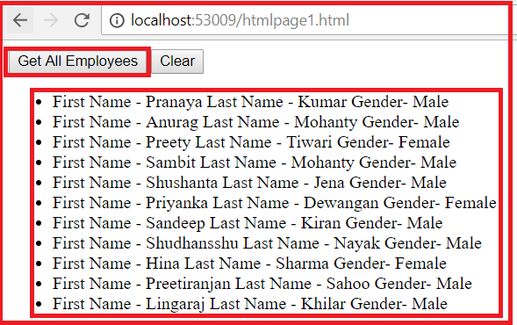

In this example, both the client (i.e. the HTML page that contains the AJAX code) and the ASP.NET Web API service are present in the same project so it worked without any problem. But, if they are present in different projects then this wouldn’t work.

**Calling Web API Service in a Cross Domain Using jQuery AJAX**

1. **What is the same-origin policy of a browser?**
2. **What do you mean by Cross-Domain?**
3. **Understanding CORS.**
4. **What is JSONP and what does it do?**
5. **How to use JSONP to call Web API Services in a Cross-Domain?**

**What is the same-origin policy of a browser?**

The browsers default behavior is that it allows a web page to make AJAX calls only within the same domain that means the browser security prevents a web page to make AJAX requests to other domains. This is called the same-origin policy.

The origin of a request consists of Scheme, Host and Port number. So, two requests are considered to be as the same origin if they have the same scheme, same host and same port number. If any of these differ, then the requests are considered to be cross-origin, i.e., not belonging to the same origins.

**What do you mean by Cross-Domain?**

Let us understand Cross-Domain with some examples.

**The following 2 URLs have the same origin**

**http://localhost:1234/api/Employee/GetEmployees**

**http://localhost:1234/Home/Index**

**The following 2 URLs have different origins because they have different port numbers (1234 v/s 5678)**

**http://localhost:1234/api/Employee/GetEmployees**

**http://localhost:5678/Home/Index**

**The following 2 URLs have different origins because they have different domains (.com v/s .net)**

**http://example.com/api/Employee/GetEmployees**

**http://example.net/Home/Index**

**The following 2 URLs have different origins because they have different schemes (http v/s https)**

**https://example.com/api/Employee/GetEmployees**

**http://example.net/Home/Index**

To prove browsers do not allow cross-domain AJAX calls, let’s create a new ASP.NET MVC application. Name it as **MVCClient** as shown below.

**Open Visual Studio and create a new project**

From the Visual Studio context menu, select **File => New => Project** as shown below



In the “**New Project**” window select “**Visual C#**” under the “**Installed – Templates**” and from the middle pane select the “**ASP.NET Web Application”** and name the project as “**MVCClient**” and then click on the “**OK**” button as shown in the below image

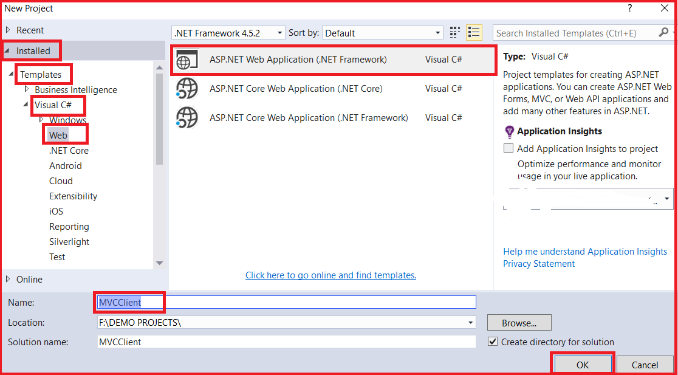

Once you click on the **OK** button, then a new popup window will open with Name **New ASP.NET Project** for selecting project Templates and from that window, we are going to select the **MVC** project template. Next, we need to select the Authentication type for doing that, we just click on Change Authentication button, a new dialog will pop up with the name “**Change Authentication**” here we are going to select **No Authentication** option and then click on the **OK** button as shown in the below image.

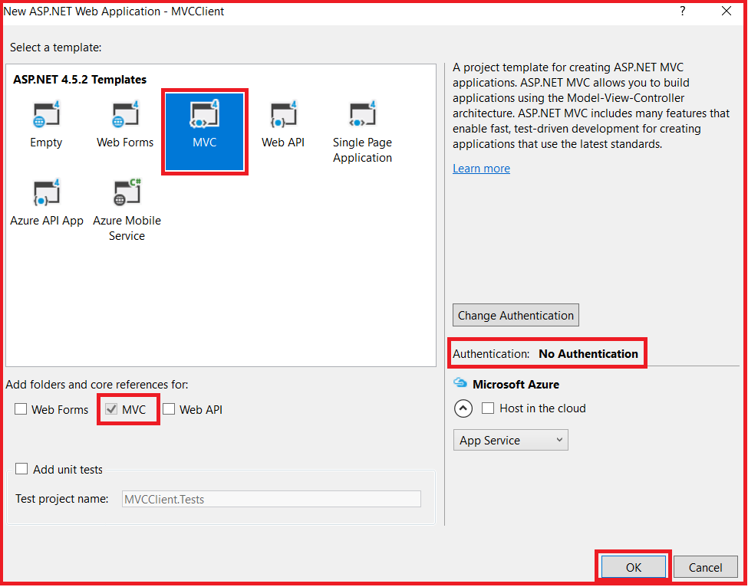

Once you click on the OK button, It will take some to time create the project for us.

**Add an HTML page.**

Right-click on the project then select **Add => Html Page** as shown below



Provide the Name as **HtmlPage1.html** and click on the **Ok** button as shown below.



Copy and paste the following HTML and jQuery code in HtmlPage1.html file.

<!DOCTYPE html>

**<html>**

**<head>**

**<title></title>**

**<meta** charset="utf-8" **/>**

**<script** src="Scripts/jquery-3.3.1.js"**></script>**

**<script** type="text/javascript"**>**

$(document).ready(function () {

var ulEmployees = $('#ulEmployees');

$('#btnGetEmployees').click(function () {

$.ajax({

type: 'GET',

// Make sure to change the port number to

// where you have the employee service

// running on your local machine

url: 'http://localhost:53009/api/Employees/GetEmployees',

dataType: 'json',

success: function (data) {

ulEmployees.empty();

$.each(data, function (index, val) {

ulEmployees.append('**<li>** First Name - ' + val.FirstName + " Last Name - " + val.LastName + " Gender- " + val.Gender + '**</li>**');

});

}

});

});

$('#btnClear').click(function () {

ulEmployees.empty();

});

});

**</script>**

**</head>**

**<body>**

**<div>**

**<input** id="btnGetEmployees" type="button" value="Get All Employees" **/>**

**<input** id="btnClear" type="button" value="Clear" **/>**

**<ul** id="ulEmployees" **/>**

**</div>**

**</body>**

**</html>**

Now first run the Service Project. Then run **HtmlPage1.html** file from the client project. When you click on the **“Get All Employees”** button on **“HtmlPage1.html”** page, you get the following error. To see the error launch browser tools and click on the console tab.

**Failed to load http://localhost:53009/api/Employee/GetEmployees: No ‘Access-Control-Allow-Origin’ header is present on the requested resource. Origin ‘http://localhost:62611’ is therefore not allowed access.**

On the other hand, when you click on the **“Get All Employees”** button on **“HtmlPage1.html”**page that is present in the same project as the ASP.NET Web API Service, the employee data is displayed without any problem. So this proves, browsers do not allow cross-domain AJAX requests. There are 2 ways to get around this problem

1. Using JSONP (JSON with Padding)
2. Enabling CORS (Cross-Origin Resource Sharing)

In this article let’s use **JSONP** to overcome the browser cross-domain restriction. In our next article, we will discuss enabling [**CORS**](https://dotnettutorials.net/lesson/cross-origin-resource-sharing-web-api/).

**What is JSONP and what does it do?**

JSONP stands for JSON with Padding. The job of JSONP is to wraps the data into a function. For example, if you have the following JSON object

**{**  
**“FirstName”: “Pranaya”,**  
**“LastName”: “Kumar”,**  
**“Gender”: “Male”**  
**}**

**JSONP will wrap the data in a function as shown below**  
**CallbackFunction({**  
**“FirstName”: “Pranaya”,**  
**“LastName”: “Kumar”,**  
**“Gender”: “Male”,**  
**})**

Browsers allow consuming **JavaScript** (JavaScript function) that is present in a different domain but not data. Since the data is wrapped in a JavaScript function, this can be consumed by a web page that is present in a different domain.

Steps to make ASP.NET Web API Service return JSONP formatted data and consume it from a cross-domain AJAX request

**Step1:** To support JSONP format, execute the following command using NuGet Package Manager Console which installs WebApiContrib.Formatting.Jsonp package.

**Install-Package WebApiContrib.Formatting.Jsonp**

**Step2: M**odify the Register() method of WebApiConfig class in WebApiConfig.cs file in App\_Start folder of our web API project.

**public** **static** **class** WebApiConfig

**{**

**public** **static** **void** Register**(**HttpConfiguration config**)**

**{**

// Web API routes

config.MapHttpAttributeRoutes**()**;

config.Routes.MapHttpRoute**(**

name: "DefaultApi",

routeTemplate: "api/{controller}/{action}/{id}",

defaults: new **{** id = RouteParameter.Optional **}**

**)**;

var jsonpFormatter = new JsonpMediaTypeFormatter**(**config.Formatters.JsonFormatter**)**;

config.Formatters.Insert**(**0, jsonpFormatter**)**;

**}**

**}**

**Step3:** In the ClientApplication i.e. MVCClient project, set the dataType option of the jQuery ajax function to jsonp

**dataType: ‘jsonp’**

**Complete Code:**

<!DOCTYPE html>

**<html>**

**<head>**

**<title></title>**

**<meta** charset="utf-8" **/>**

**<script** src="Scripts/jquery-3.3.1.js"**></script>**

**<script** type="text/javascript"**>**

$(document).ready(function () {

var ulEmployees = $('#ulEmployees');

$('#btnGetEmployees').click(function () {

$.ajax({

type: 'GET',

// Make sure to change the port number to

// where you have the employee service

// running on your local machine

url: 'http://localhost:53009/api/Employees/GetEmployees',

dataType: 'jsonP',

success: function (data) {

ulEmployees.empty();

$.each(data, function (index, val) {

ulEmployees.append('**<li>** First Name - ' + val.FirstName + " Last Name - " + val.LastName + " Gender- " + val.Gender + '**</li>**');

});

}

});

});

$('#btnClear').click(function () {

ulEmployees.empty();

});

});

**</script>**

**</head>**

**<body>**

**<div>**

**<input** id="btnGetEmployees" type="button" value="Get All Employees" **/>**

**<input** id="btnClear" type="button" value="Clear" **/>**

**<ul** id="ulEmployees" **/>**

**</div>**

**</body>**

**</html>**

Now run the service application first. Then run the client application and navigate to the URL “**http://localhost:61757/HtmlPage1.html**” and click on **Get All Employees** which will display all the employees’ information.

**Cross-Origin Resource Sharing in WEB API**

1. **What are the same-origin policy and default behavior of browsers in AJAX Requests?**
2. **What is CORS?**
3. **How to enable CORS in Web API?**
4. **Understanding the Parameters of EnableCorsAttribute.**
5. **How to use EnableCors attribute at the Controller and action method level?**
6. **How to Disable CORS?**

**What are the same-origin policy and default behavior of browsers in AJAX Requests?**

Browsers allow a web page to make AJAX requests only within the same domain. Browser security policy prevents a web page from making AJAX requests to another domain. This is called the same-origin policy. In other words, it is a known fact that browser security prevents a web page of one domain from executing AJAX calls on another domain.

**What is CORS?**

CORS is a W3C standard that allows you to get away from the same-origin policy adopted by the browsers to restrict access from one domain to resources belonging to another domain. You can enable CORS for your Web API using the respective Web API package (depending on the version of Web API in use).

**Changes to Web API project:**

Delete the following 2 lines of code in the **Register**() method of **WebApiConfig** class in **WebApiConfig.cs** file in **the App\_Start folder**. We added these lines in our previous articles to make ASP.NET Web API Service return JSONP formatted data

**var jsonpFormatter = new JsonpMediaTypeFormatter(config.Formatters.JsonFormatter);**  
**config.Formatters.Insert(0, jsonpFormatter);**

Your **WebApiConfig** class should look as shown below.

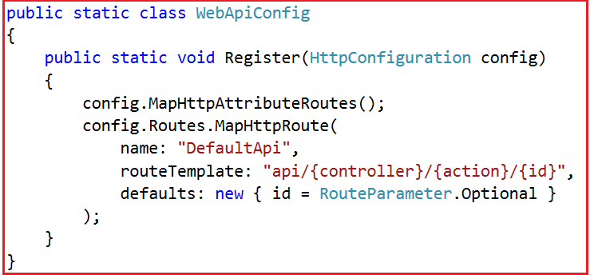

**How to enable CORS in Web API?**

**Step1:**Install **Microsoft.AspNet.WebApi.Cors** package. Execute the following command using the NuGet Package Manager Console.

**Step2:** Include the following 2 lines of code in **Register()**method of **WebApiConfig**class in **WebApiConfig.cs** file in **App\_Start**folder

**EnableCorsAttribute cors = new EnableCorsAttribute(“\*”, “\*”, “\*”);**  
**config.EnableCors(cors);**

After adding the above two lines of code, the **WebApiConfig**class should as shown below.

**public** **static** **class** WebApiConfig

**{**

**public** **static** **void** Register**(**HttpConfiguration config**)**

**{**

// Web API routes

config.MapHttpAttributeRoutes**()**;

config.Routes.MapHttpRoute**(**

name: "DefaultApi",

routeTemplate: "api/{controller}/{action}/{id}",

defaults: new **{** id = RouteParameter.Optional **}**

**)**;

EnableCorsAttribute cors = new EnableCorsAttribute**(**"\*", "\*", "\*"**)**;

config.EnableCors**(**cors**)**;

**}**

**}**

The following 2 lines of code in Register() method of **WebApiConfig.cs** file in **App\_Start** folder enables CORS globally for the entire application i.e. for all controllers and action methods

**EnableCorsAttribute cors = new EnableCorsAttribute(“\*”, “\*”, “\*”);**  
**config.EnableCors(cors);**

**Step3:** In the Client Application, set the dataType option of the jQuery ajax function to JSON **dataType: ‘json’**

Now run the service first and then the client application and check everything is working as expected.

**Parameters of EnableCorsAttribute**

**Origins:**A comma-separated list of origins that are allowed to access the resource. For example “**https://www.dotnettutorials.net, https://www.something.com**” will only allow ajax calls from these 2 websites. All the others will be blocked. Use “**\***” to allow all

**Headers**: A comma-separated list of headers that are supported by the resource. For example “**accept,content-type, origin**” will only allow these 3 headers. Use “**\***” to allow all. Use the null or empty string to allow none

**Methods**: A comma-separated list of methods that are supported by the resource. For example “**GET, POST**” only allows Get and Post and blocks the rest of the methods. Use “**\***” to allow all. Use a null or empty string to allow none

**How to use EnableCors attribute at the Controller and action method level?**

It is also possible to apply the EnableCors attribute either at the controller level or at the action method level. If applied at a controller level then it is applicable for all methods in that controller. Call the EnableCors() method without any parameter values.

**Apply the EnableCorsAttribute on the controller class**

**[**EnableCorsAttribute**(**"\*", "\*", "\*"**)]**

**public** **class** EmployeesController : ApiController

**{**

**}**

**In the same manner, we can also apply it at a method level if we wish to do so.**

**public** **class** EmployeeController : ApiController

**{**

**[**HttpGet**]**

**[**EnableCorsAttribute**(**"\*", "\*", "\*"**)]**

**public** IEnumerable**<**Employee**>** GetEmployees**()**

**{**

EmployeeDBContext dbContext = new EmployeeDBContext**()**;

**return** dbContext.Employees.ToList**()**;

**}**

**}**

To disable CORS for a specific action apply **[DisableCors]** on that specific action.